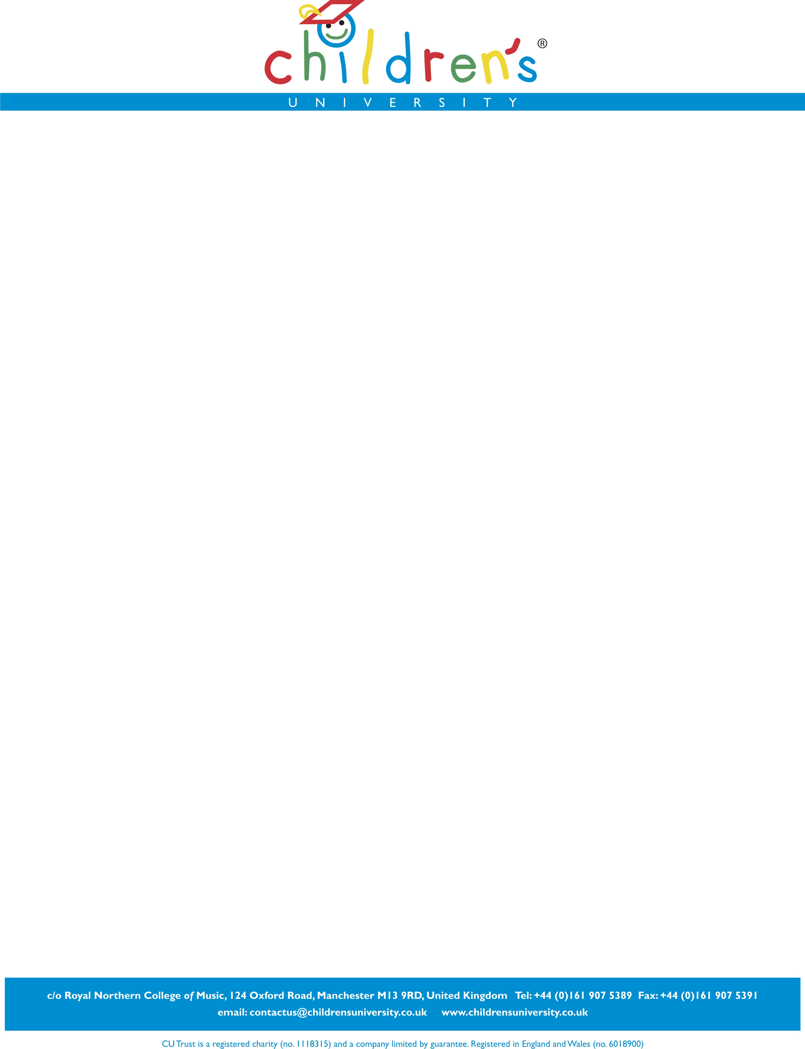

Children’s University ‘Passport To Learning’

ORDER FORM

CHILDREN’S UNIVERSITY:
NUMBER OF PASSPORTS REQUIRED:
(in multiples of 250; £2.50 per passport payable to CU Trust)
FULL DELIVERY ADDRESS:

POSTCODE:
PREFERRED DELIVERY DATE:  (please allow 10 working days)  TIME:  (please specify) | / /  AM / PM / DON’T MIND
SPECIAL DELIVERY INSTRUCTIONS:

ORDER NUMBER:
(if applicable)
INVOICE ADDRESS:
(if different from the above)

SIGNED:

PLEASE PRINT NAME:

DATE:

Please complete and return to the Children’s University head office:

Address: Children’s University, Room 103, c/o Royal Northern College of Music, 124 Oxford Road, Manchester, M13 9RD

Fax: 0161 907 5391

Office use only:
Date received: / /

Date processed: / /

