16th April 2007 … and five years on! Many thanks to all who have travelled with us, either all the way or part of it. And Happy Birthday of course! We have always said that the Children’s University is like a colouring-in book: the picture is drawn but the colours and the sparkle are applied locally … so off you go – get your crayons and have fun (5 years of it!). The new Achievements and Developments is out soon highlighting what’s gone on in 2011 and what the plans are for the next twelve months – a little peek: £4.25 million income over 5 years, 160,000 Passports To Learning in use, 2,750 Learning Destinations, 100,000 children participating in 2011 for 2-plus million hours in 80 CU centres in England alone …!!! And then there are all the others of course … Isle of Man, Northern Ireland (soon), Scotland and Wales!! And then there will be all the others of course … the Netherlands, Malaysia!

It’s like buying a new pair of shoes … and then wearing them in! You like them, no … you love them, your parents pay for them and then you wear them on a night out! They’re stiff, a little uncomfy, they give you a few blisters and at some point make you wish you hadn’t thrown the old one away …! But after a few nights out they will become the bees’ knees!!!

Welcome the new www.childrensuniversity.co.uk ! And many many thanks to all those who have made this possible over the last twelve months or so: Fidelity Foundation for the funding, Bit10 and Exasoft for the development and in particular Mo, Anne-Marie, Steve, Liam, Lilly, Andre, Mark and Alan … our Triinu and Lynne and of course everyone I have forgotten to mention here …! The website will be introduced in bits and part one is here now … part two, with things like a ‘CU Members’ area will follow in June and further updates in the autumn and winter of 2012.

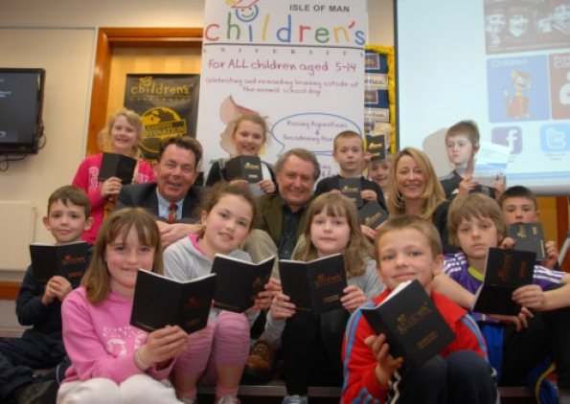
And we’re off: the Isle of Man CU formally launches

On 29th March 2012 the Isle of Man Children’s University had its formal launch at the wonderful Scoill Valljeelt in the presence of the Isle of Man CU Chancellor and wildlife artist Dr Jeremy Paul. Well done to Carys Lloyd for two years of sheer persistence and determination, hard work and inspiration! Thanks too to John Gill for all his support … Graduation in March 2013!!!

CU Nederland … How good does that sound? Meet the two newest drivers of Children’s University development Dr Lenie van den Bulk and Maryse Bolhuis. Hartelijk welkom!! We hope to get things off the ground swiftly but it does involve translation of key documentation such as Planning for Learning and Planning for Volunteering as well as the Passport To Learning of course. Maryse and Lenie represent the CED Groep from Rotterdam and will be looking for all our support and patience in the next few months in order to get things growing properly … starting in Rotterdam! Onze familie zal jullie natuurlijk heel graag helpen – gewoon even maar bellen als hulp (of een schouder) nodig of gewenst is!!

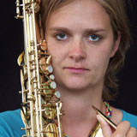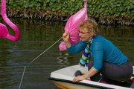
Maryse plays clarinet … and Lenie appears to sail

Validation training took place in March in Devon and Torbay, Leicester, Colchester and Nottingham … Warrington, Peterborough and Sandwell are on the cards for the rest of April. Keep an eye on the website for future dates as well.

Also this month: NICU or Northern Ireland Children’s University is about to get off the ground thanks to the determination and inspiration that is Keith Wysner … so keep an eye on the next bit of the British Isles to join the family! Keith is the Principal at Knockloughrim Primary School and has done a tremendous amount of work already to get partners and potential Learning Destinations on board including the South West Regional College as a key coordinating partner!

Keith going to work … smiling of course

Because we didn’t have our usual regional CU Managers’ meetings this March we will be emailing a bit of an update to all local CUs with bit, pieces, dates and a few things to consider … so keep an eye out for that as well!!

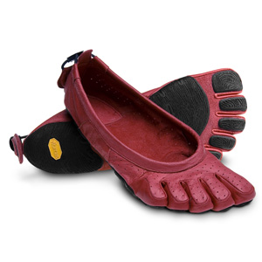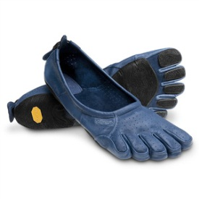
Aaaah …! The shoes are getting better already (and so is the website!!) – We’ll be used to them all before we know it!

TTFN!

