**Ooh aah … raise the bar**

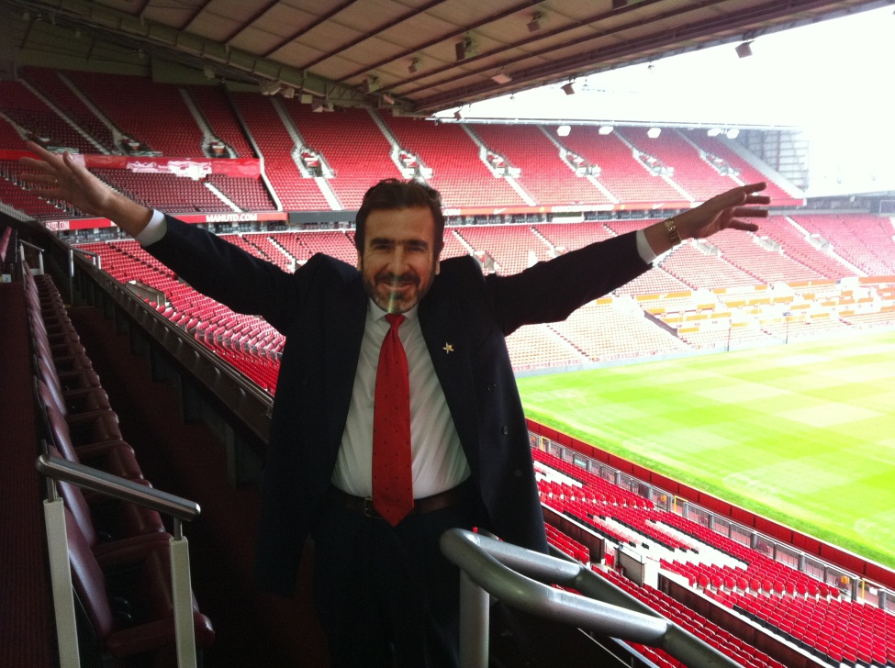

How good of Eric to drop by and say “Bonjour” last week! Many thanks to all of the Children’s University professionals who attended our one day summer gathering at The Theatre of Dreams in Manchester … the thing just grows and grows! It was wonderful to welcome representation from The Netherlands as our latest CU members – welkom Lenie en Maryse! Het was heel leuk dat jullie hier waren (just showing off now!). In total there were nearly 90 of us at Old Trafford … at our first ever meeting on 12th July 2007 there were 9! Not bad eh …?!

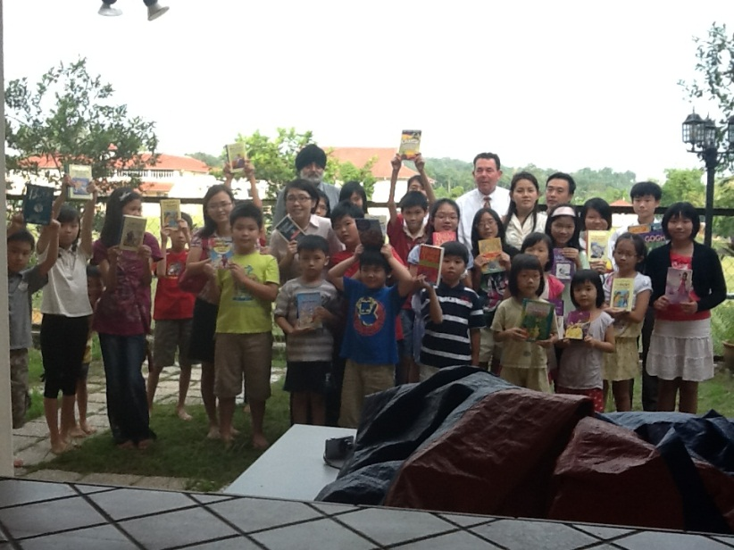

*A reading club in Kuala Lumpur … and a future CU Learning Destination?*

The week before I attended a series of meetings in Kuala Lumpur with representatives of the Malaysian Ministry of Education, the Asia E University and our partners from the Di Purba Centre for Professional Excellence … there is a real interest in developing a Children’s University presence in Malaysia and plans are progressing as to how to take this forward. Nottingham University also has a prominent presence in Kuala Lumpur and has already started to advise us so that we are able to understand local contexts better which will then enable us all to do the right (and fun and exciting) things for children and young people in CU Malaysia … Watch this space!

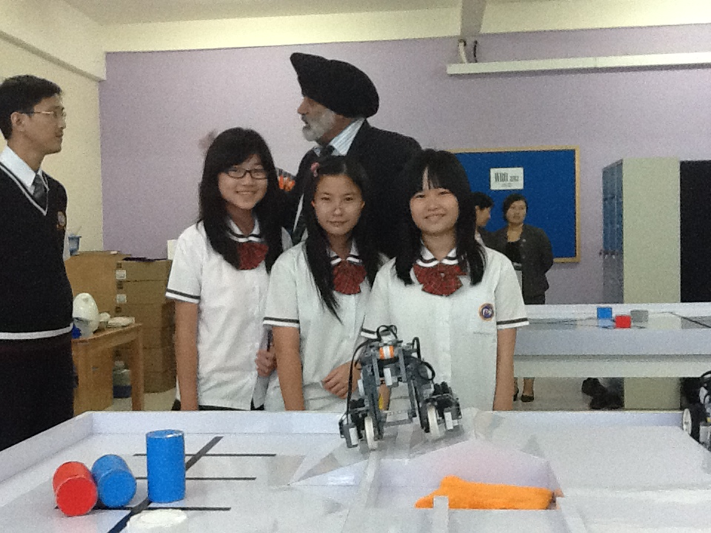

*PrimeOne School’s ‘Robotics’ club in Medan, Indonesia*

A flying visit to Medan in Indonesia was also on the agenda … led by the PrimeOne School in Medan, it is likely that the Children’s University will thrive across the city for all children – and then, who knows?

In both cases the children were just completely amazing … can’t wait to see them again! Malaysian and Indonesian representatives are expected at this year’s 5th annual CU Conference in December … as are representatives from South Australia and the University of Adelaide!!



*Twinkle twinkle … Raise the bar!*

The theme of this year’s conference will be along the lines of ‘Twinkle twinkle … Raise the bar!’ and it will include the usual Market Place, key notes and ‘think-shops’ – the harder we are made to work the more we need to make room to think … so no more work-shops for a bit!! The dates are 10th and 11th December, the venue Shrigley Hall near Macclesfield and more info will be available from early September.



*21st January 2013: CU there …!*

Lord Lingfield, Patron of the Children’s University, will be hosting a reception to celebrate our successes and the end of our 5th birthday year at the House of Lords on 21st January 2013 … can’t wait!!

Silethokuhle Sibanda is 14 and she is from Rotherham. Sile will be at the reception at the House of Lords in January 2013 … Silethokuhle Sibanda is one of the most astonishing young people I have ever met – she spoke at a regional Children’s University conference at the Magna Science Adventure Centre in Rotherham and she completely blew everyone away!!! And she is totally fab too!! If you don’t believe me …



## At [~~@~~MagnaScience](http://twitter.com/#!/MagnaScience) very inspiring morning with [~~@~~cu_trust](http://twitter.com/#!/cu_trust). Young rep Sile Sibanda was almost too much; [~~#~~tears](http://twitter.com/#!/search/%23tears); she's off to the House of Lords!

On 14th June Dr Sandy Bradbrook, Chair of the CU Trust, and I attended the 2012 Charity Awards at the Grosvenor Hotel in London. 185,000 charities in the UK and we were on a shortlist of 32!! The outcome:



Chuffed to bits … and we will of course encourage all of our local CU centres to use the award logo as much as we will!! The truth ..? I am not an ever so good loser …!

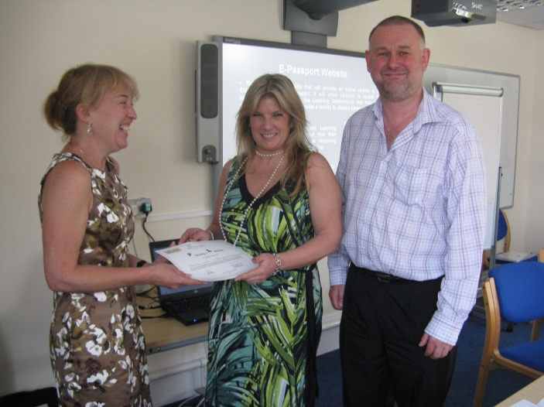

*The 1,000th CU Validator Natalie Hyman (centre)*

Natalie Hyman from Nottinghamshire became our 1,000th CU Validator at a recent training event there! 1,000 Children’s University professionals now use ‘Planning for Learning’ to validate learning provision across the country (and beyond) so that our CU students get a good deal. Natalie is pictured above with Tricia Allen and Andy Nicklin from Nottingham & Nottinghamshire Children’s University.



*Either awe and wonder … or the hat is stuck!*

It’s graduation time: from Liverpool to Hull, from Sefton to Dorset, from Redcar and Cleveland to Havant, Colchester, Nottinghamshire, Northamptonshire, Lambeth, West London, Walsall, Birmingham, Norfolk, Suffolk, Chesterfield, Doncaster, South Hertfordshire, Blackburn, Bolton, Carlisle, Wolverhampton, Slough, York, Knowsley, Rotherham, Colchester, Derby, Coventry, Service Children’s Education … and no doubt there is one missing! We try to get to them all … watch out for the piccies!! Looking forward to seeing Robyn and Henry in Paderborn next week … ☺

Lauren Hill from Chesterfield is special and I will be seeing her for tea and biscuits (lemonade and choccies!!) next week … 1,030 hours – that’s how special she is!!!



If you want a bit of a read:

[www.childrensuniversity.co.uk/media/232229/achievements_and_developments_2012.pdf](http://www.childrensuniversity.co.uk/media/232229/achievements_and_developments_2012.pdf)

or see something “amaaazin’ …”

[www.youtube.com/watch?v=e9Dq-IYzjXs&list=UU_o5XUDiTR6ibQK0_5M2DwA&index=1&feature=plcp](http://www.youtube.com/watch?v=e9Dq-IYzjXs&list=UU_o5XUDiTR6ibQK0_5M2DwA&index=1&feature=plcp)

We’re off graduating!

TTFN!

