

**Happy Olympics ..!**

The excitement is everywhere … from the bridges across the Tyne in Newcastle to Old Trafford and from Harpfield Primary School in Stoke to the Royal Holloway University in London, from Service Children’s Education in Germany to Knockloughrim Primary School’s community in Northern Ireland, from Borders to Douglas and from Cardiff to … well everywhere really! So enjoy and *“Happy Olympics”* from all of us @CU_Trust to all of you @Where_ever (and particularly to all the children of course!!)!



*Slough CU graduates at Royal Holloway University*

Where to start? Well … Colchester, Rotherham, Lambeth, Walsall, Birmingham, Germany, York, South Hertfordshire, West London, Doncaster, Blackburn, Wolverhampton, Slough, Stoke, Coventry, Nottinghamshire, Liverpool, Hull, Sefton, Knowsley, Redcar and Cleveland, Havant, Northamptonshire, Bolton, Norfolk, Suffolk, Chesterfield, Carlisle, Derby (and some of these more than once …!) … and now someone is going to get in touch to say *“You missed one …!”* – I am proud to say that we made nearly all the graduation ceremonies and we certainly enjoyed all of the ones we got to!! Many congratulations to all our CU students and to their proud mums and dads, and many thanks to all our local Children’s Universities for making it happen!



*MAGNA Science Adventure Centre Rotherham*

## The Yorkshire CU Crew – Sheffield, Doncaster, Barnsley, Rotherham, Leeds and Bradford – organised a regional Children’s University Conference for headteachers at the magical MAGNA Science Adventure Centre Rotherham … great must-visit venue and fabulous event!

## http://diamonds.blogs.com/.a/6a00d83421e3fa53ef0120a5a8ae05970b-200wi

## *Sile has more carats than this …!*

## And there - at the Yorkshire CU Crew ‘Do’- a diamond was discovered … Sikethokuhle Sibanda (or Sile to her friends) – just hang on to the name and remember for now!! The largest diamond crystal ever found was the ‘Cullinan’, at 3,106.75 carats; from that crystal, the ‘Great Star of Africa’ was cut weighing 530 carats … multiply that by a zillion carats and you might just have met Sile (I am her friend you see☺)!!!

## Sir William Atkinson, headteacher of Phoenix high school, London

## *Sir William Atkinson, Executive Headteacher of the Phoenix Canberra Schools Federation*

## Cambridgeshire, Northumberland, Bournemouth and Poole, New Forrest, East Sussex and the Phoenix Canberra Schools Federation in Hammersmith & Fulham are our new kids on the block … it’ll take us a little while to get them all going but when they do, they will all bring their sprinkling of CU magic to the party!

## Jock Brown

## *Welcome to Jock Brown*

## Developments in Scotland are also afoot following a meeting I had with our Chair Dr Sandy Bradbrook and his former university buddy Jock Brown. Jock Brown graduated from Cambridge University in English Law but returned to qualify as a solicitor in Scotland more than 30 years ago. Jock is also well known in the footballing world … He had a spell as General Manager, Football, at Celtic Football Club in the late nineties and is also widely known for his work as a sports broadcaster, having commentated on major football and golf events over the past three decades. Jock loves what we do and will be instrumental in establishing a CU Trust Scotland … roll on September when we will start this bit of development in earnest!

## http://www.sezl.nl/afbeeldingen/Logo-CED.jpg

## *The Dutch are coming … so is the future orange?*

The 9th October 2012 is the official launch date of the CU in the Netherlands. A launch event is planned in Rotterdam where the CED Groep will lead on Children’s University developments, initially in partnership with the city of Rotterdam and the Erasmus Universiteit.



*Sunday Times Education Festival 2012*

Apart from the regional CU conference at MAGNA in Rotherham, the Children’s University had key slots at the National Union of Teachers Education Conference and at the Sunday Times Education Festival 2012 – thanks to Professors John MacBeath and Tim Brighouse, CU Patrons Dr James Bradburne and Hilary Robinson, and Doncaster FE College Principal George Trow (Hilary’s blog [www.huffingtonpost.co.uk/**hilary**-**robinson**/](http://www.huffingtonpost.co.uk/hilary-robinson/) is of course a right riveting read!).

I also managed to have a little time at the University College Cork in Ireland with Professor Kathy Hall and her colleagues thinking and discussing Loris Malaguzzi’s work and that of Reggio Children … many thanks for the thoughts!

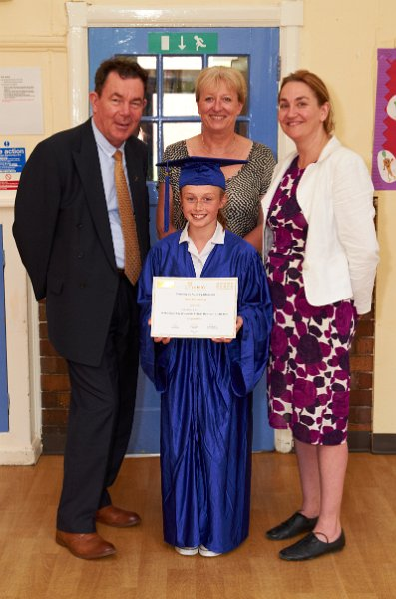

*Lauren Hill, the first CU Fellow… and a few grown-ups too*

*(including Headteacher Janet Baxter and local MP Natascha Engel)*

And that’s Lauren Hill, our very first Children’s University Fellow … 1,000+ hours (1,030 hours in fact) of CU learning beats the lot! Lauren has just finished her last year at Temple Normanton Primary School in Derbyshire but somehow I think we will see more of her in the future, perhaps even at the 2016 Olympics in Rio – she is a bit of a gymnast too apparently …!!

Alisha McLean and Lucy Clark from Overfields Primary School in Redcar and Cleveland Children’s University followed hot on Lauren’s heels *… “for they are jolly good CU Fellows too of course”*!!!



Late 13c., *"beginning"*; early 15c., *"tempering, refining of something to a certain degree”*; early 15c., *"action of receiving or giving an academic degree"*; 1894*, "student formal dance in celebration of graduation”* …

Just a bit of food-for-graduation thought!!!

Graduations …? Have a look at what the youngsters from Colchester Children’s University make of it (and Debbie didn’t know but shed a little tear after seeing this!) …

http://vimeo.com/38150441

And finally: new partnerships …? More than you can shake an Olympic relay baton at: Natural History Museum, more B&Q, Esmee Fairbairn, Random House publishers, KidZania … *“Kid-what?”* I hear someone say … yes, KidZania and watch this and that space …!!

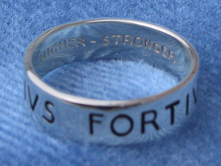

*Citius, Altius, Fortius … a ring of commitment?*

*Faster, Higher, Stronger* or *Citius, Altius, Fortius* … it’s about celebrating what we are capable of – and that’s amaaaazin’! And that surely is the reason to enjoy …!

Oh … and have a great summer too!!

TTFN!

