ARCHIVE – THURSDAY, JULY 5, 2012

It’s hats off to primary pupils
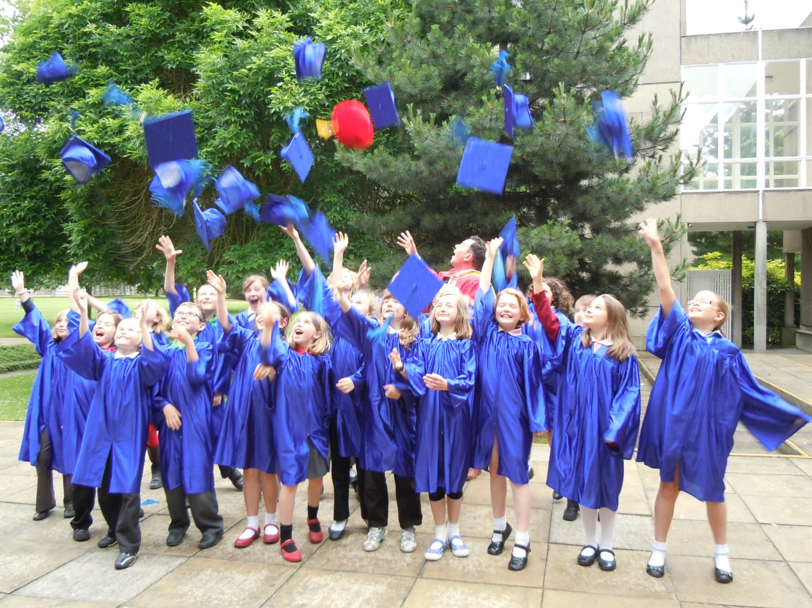

CELEBRATION: Primary school children from York Children’s University celebrate their graduation with
Chief Executive Ger Graus.

TWENTY-ONE children, all aged under 12, made history when they became the first ‘graduates’ from York Children’s University.
The pupils from Carr Junior School, Scarcroft Primary School and Yearsley Grove Primary School had each completed 30 hours of out of school learning with some of York’s employers and museums under a scheme run by employee-volunteering charity York Cares.
The project is part of a national campaign to inspire disadvantaged children aged seven to fourteen by linking learning with real life.
As well as taking part in a wide range of after school clubs, the York children also visited the National Centre for Early Music, Jorvik Viking Centre, the Quilt Museum and York Museums Trust properties, York Theatre Royal and York Arts Academy.
Sarah Wright, deputy head of Yearsley Grove School, said: “York Children’s University has been a great way to increase children’s motivation, and it’s wonderful to see how proud they are of their achievements. Out of school learning makes a real difference to children’s achievement, so it’s wonderful that this scheme is encouraging children to get engaged in such a variety of activities.”
York Cares is now hoping to expand its programme following this year’s success and is looking for more organisations willing to provide extra-curricular activities.

