**And the winner is …**

All the children and young people who are ‘signed up’ to their local Children’s Universities …!!!!!!

It was great to receive The Third Sector Excellence Award 2012 a few weeks ago – *‘Small Charity, Big Achiever’* … it is brilliant to feel proud of what so many of us achieve collectively! So, the Award itself is in the bag and will be travelling the country with me over the next few weeks to share locally with the children and young people as well as all the grown-ups of course, including all of our CU *Learning Destinations* …!

[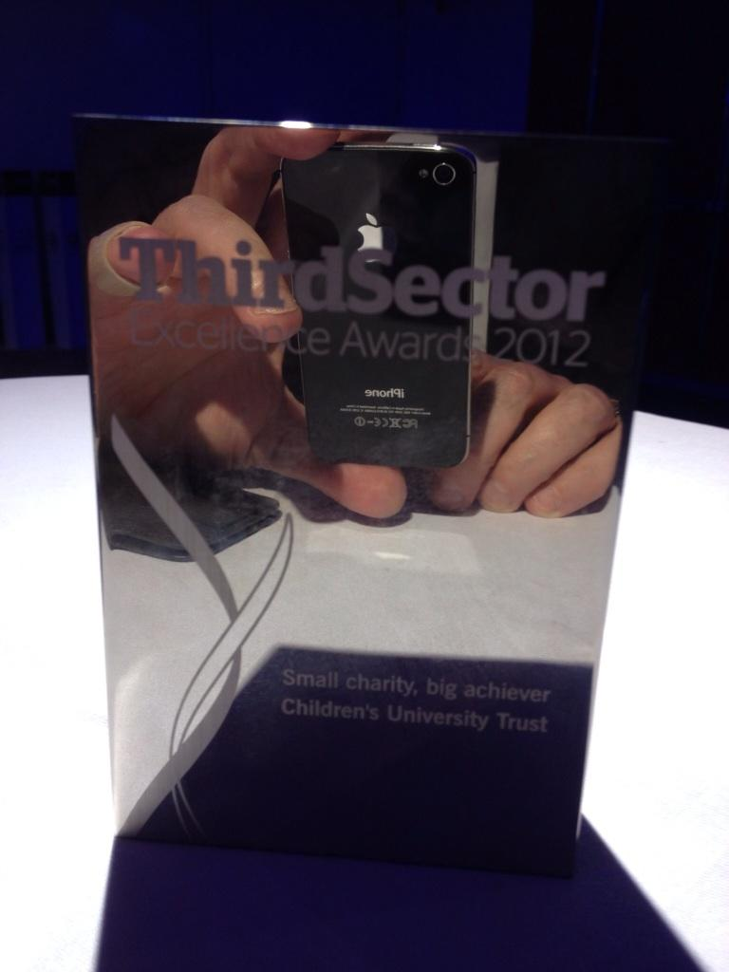](http://t.co/4DeSp0MJ)

*And the winner is …*

The logo has been emailed to all local Children’s Universities, so our achievement should be viewed from email signatures, letterheads and websites …

[](http://t.co/llFfGqYG)

We have also been shortlisted for two further national awards and we should know by the end of November how well we’ve done in these!

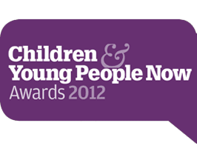

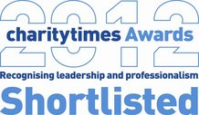

Off to the Netherlands this month too … Lenie and Maryse are looking to formally launch CU Nederland in Rotterdam on 9th October and it will be a real privilege to be there when that happens; it will be interesting to meet all the Dutch local CU ‘shareholders’ and particularly talk to the children and young people about what their expectations are … And I have been promised “friet met mayonaise” ..!!



*Friet met mayonaise*

The Children’s University in Scotland is gathering momentum … Following a series of meetings in Glasgow, Edinburgh, East Lothian and Borders we are now looking to establish CU Scotland as a charity in its own right – following the CU Isle of Man and CU Northern Ireland models – with Strathclyde and Queen Margaret Universities as the trail blasers for CUs in Glasgow and hopefully East and Mid Lothian too. The rest will follow …

The Scottish initiave is driven by Jock Brown, a former fellow Cambridge University student of Sandy Bradbrook (our CU Trust Chair) and is supported by Professor John MacBeath (more Cambridge!) and the Vice-Chancellors of Strathclyde and Queen Margaret Universities; Scottish Power is also getting very warmed up about a CU presence in Scotland … Watch this space!



*Jock and John … driving forces in CU Scotland*

Interest has also been registered in Estonia (our Triinu’s home patch), Nanjing in China, Singapore and India (maybe, just maybe in partnership with an organisation called [www.goingtoschool.com](http://www.goingtoschool.com))



*The graduates …*

Back in England meanwhile more graduations are the order of the day with Warwickshire, Essex, Plymouth, Stoke, Walsall and Cornwall all on the horizon and Leicester, Croydon, Middlesbrough and Northamptonshire been and gone! Northamptonshire had its first CU Volunteers graduation, recognising the contribution of the CU Alumni at aged 15+, whilst Middlesbrough CU had its very first graduation at the very impressive town hall … and they had cake!!

[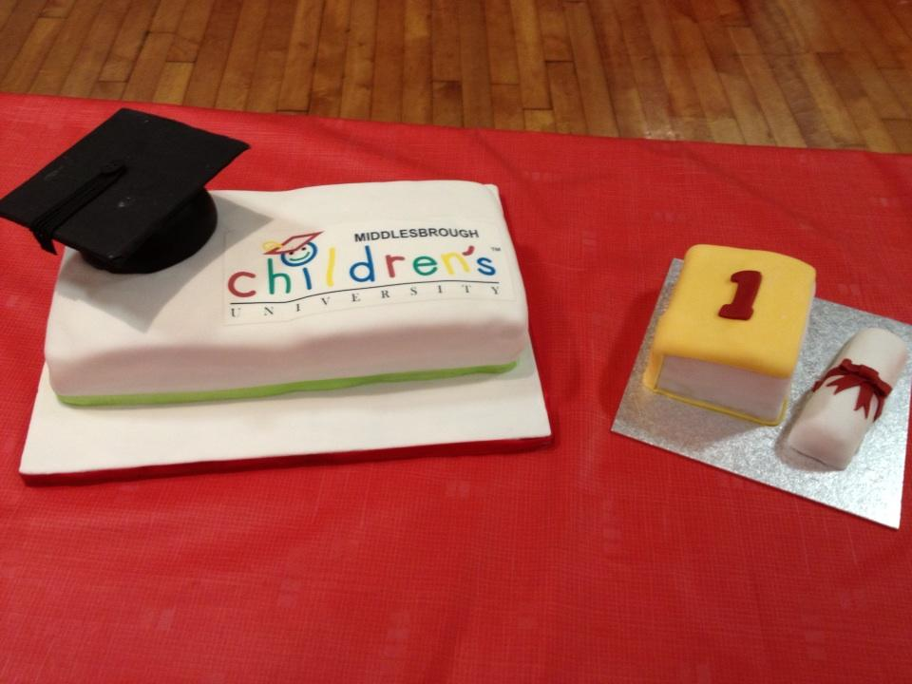](http://t.co/dPrzPqD6)

*Cake anyone …?*

Our list of local CU Chancellors is also constantly growing … the current CU Trust Chancellor is the children’s author Michael Morpurgo who has recently been joined by CU Middlesbrough’s Max Howard. Max created and ran studios for Disney working on brilliant films like *Aladdin, Lion King* and *Who Framed Roger Rabbit?* Max said of the Children’s University …

*“The Children’s University is an incredible innovation, creating an opportunity to participate in unique and fun educational programmes outside of the traditional classroom environment. I am proud to now be a part of this visionary initiative and look forward to seeing it grow from strength to strength, not only in Middlesbrough but all around the world.”*

The actor Warwick Davis meanwhile has agreed to join Peterborough Children’s University as their local Chancellor. Warwick has played a part in many a famous film including *Star Wars* and my favourite *Harry Potter* …

[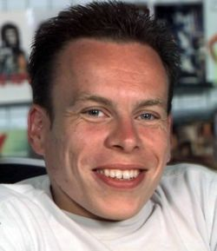](http://images1.wikia.nocookie.net/__cb20090330184758/harrypotter/images/4/4b/Warwick_Davis_1.jpg)[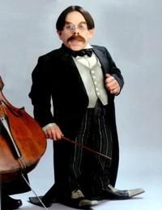](http://images1.wikia.nocookie.net/__cb20100410145421/harrypotter/images/e/e2/ProfFlitwick.jpg)

*Warwick Davis aka Professor Flitwick*

Plenty going on in and outside the office … The first CU Trust Trustees meeting of the academic year took place last week in Birmingham: good and very busy meeting, good planning, good people, good fun ..! Michelle Box was appointed on 22nd August 2012 and will formally start with the CU Trust on 15th October 2012. Michelle has worked in a PA role since 2001 across various sectors including the Royal Air Force, NHS and not-for-profit agencies both in the UK and Australia.  Michelle is currently studying a degree in Canine Behaviour and Training … Michelle is getting ready to cover Andrea’s maternity leave which will start just after the 5th annual CU conference on 10th and 11th December (she is not allowed to go before that!) – and we’ll keep you posted of course! The pressie for the little one? A passport of course!!



*Michelle*

The 5th annual Children’s University conference for CU Managers and invited guests will take place on 10th and 11th December and will focus on raising the bar for children and young people, learning and learning from each other and will again include ‘Rapid Information Exchanges’ to share what works and a ‘Market Place’ where we can learn from other key delivery partners as recommended and endorsed by the local CU centres. These include BBC Outreach, B&Q, First News, Random House Publishing, Education Through Expeditions, the Anne Frank Foundation UK, ClassMovies (Australia)…



The conference will also include think-shops specifically focusing on learning and learning in other environments including the mobile, virtual environment and how children and young people can lead in the CU through volunteering. Dr James Bradburne, Director General of the Fondazione Palazzo Strozzi, Florence (Italy), Professor Mick Waters and Professor Steve Molyneux have agreed to lead the think-shops alongside a number of Children’s University Alumni. Professor Carla Rinaldi, President of Reggio Children and of the Reggio Children Foundation – Loris Malaguzzi centre, will deliver this years’ key note address. There will also be brief contributions from CU students, CU parents and CU headteachers. In addition, Professor John MacBeath will be unveiling the main findings from the most recent evaluation. We are this year expecting representatives from across the British Isles as well as the Netherlands, Portugal, Australia, China, Malaysia and maybe even India.

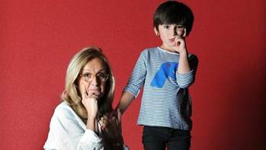

*It doesn’t get much better than Carla Rinaldi (on the left by the way)*

I am also looking forward to our regional CU Managers’ meetings in October starting in Slough on 9th and via Sunderland on 23rd finishing in Birmingham on 25th October.

And finally … Middlesbrough Children’s University’s Ethan Lamb became the recipient of the 200,000th CU *Passport To Learning* … another significant milestone in our history. Passport number 000,001 was issued in June 2009 and hangs on a wall – framed! I fully expect passport number 250,000 to be issued before the end of March 2013 …!

[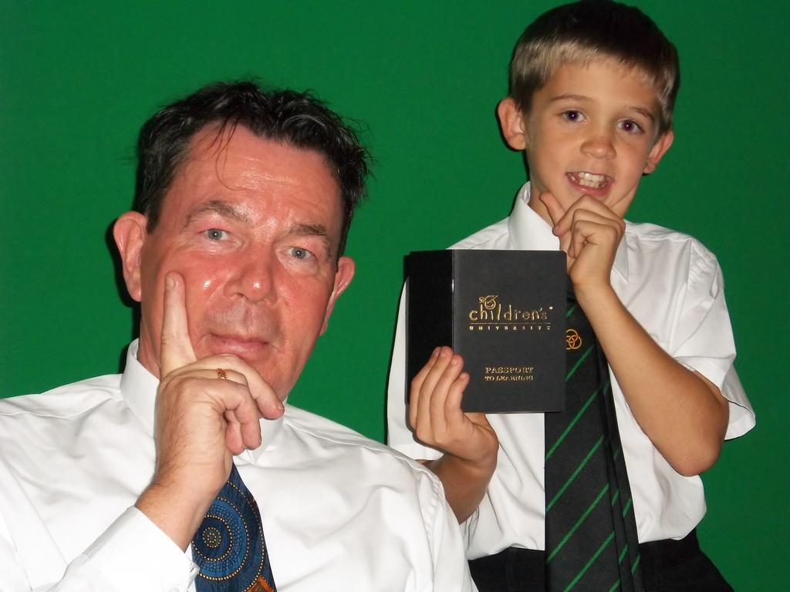](http://t.co/BuZcHJKT)

*With Ethan and the 200,000th Passport To Learning*

It’ll be a bit busy in the next few weeks: apart from the graduations and the many CU validation training sessions our Director of Learning, Lynne Upton, is running [www.childrensuniversity.co.uk/news/notice-board/](http://www.childrensuniversity.co.uk/news/notice-board/) there is the evaluation to be completed, funding applications, meetings about the management transformation to charitable status by some local CU centres, the data from all the local CU centres for 2012 to be collected and collated by mid-November, the House of Lords reception prep for January 2013, getting ready for our 5th annual CU conference … Still, it’ll keep us out of mischief! NOT!!

Ps … Picture of the year (so far)?

[](http://t.co/aeuSaGro)

*Joanna Chodzko-Zajko (West London CU) flying high …!*

TTFN!

