18.12.2012

Merry Christmas and a Happy 2013

Another year gone … well, nearly! I thought it would be good to have a bit of a look back – month by month and remind ourselves how special 2012 has been!

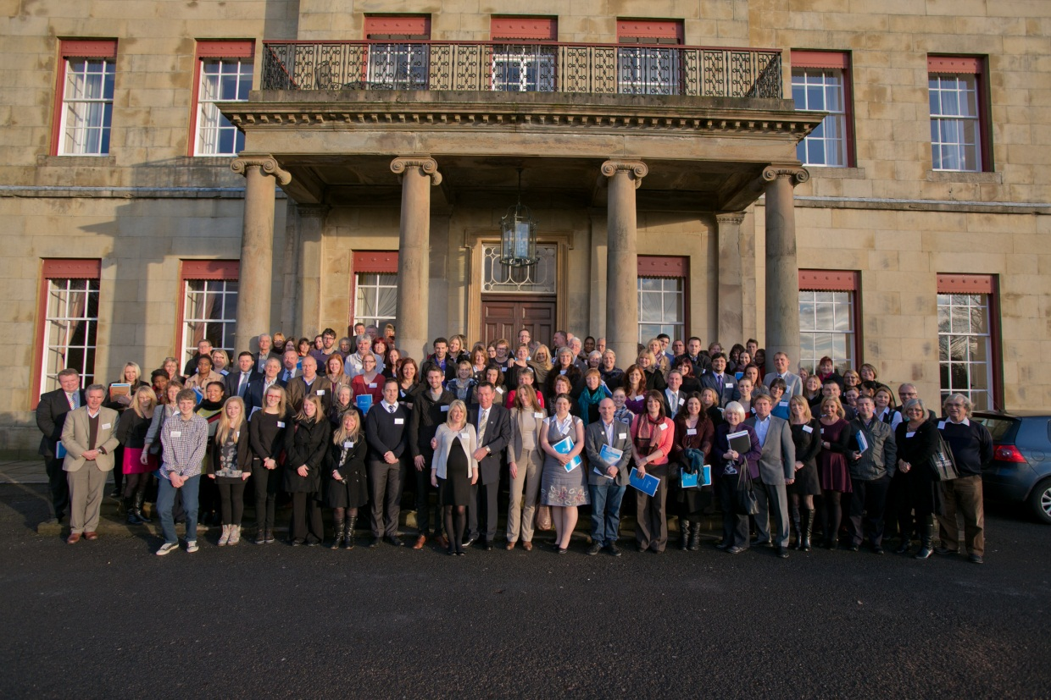
The 5th Annual CU Trust Conference at Shrigley Hall, December 2012 (with Andrea and bump!)

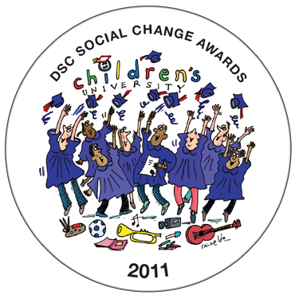
January 2012: at the end of 2011 we won …

February 2012: University of fun-run …
Jessica Cheetwood with the 150,000th CU Passport
at the Manchester Health Academy

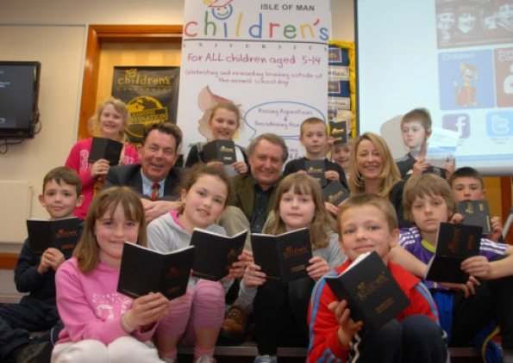
March 2012: the Isle of Man CU launches …

April 2012: Happy 5th Birthday!

May 2012: the Dutch are coming … CU Nederland

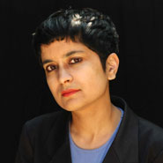
June 2012: Shami Chakrabarti becomes the latest CU Patron

and we all met at the Theatre of Dreams …

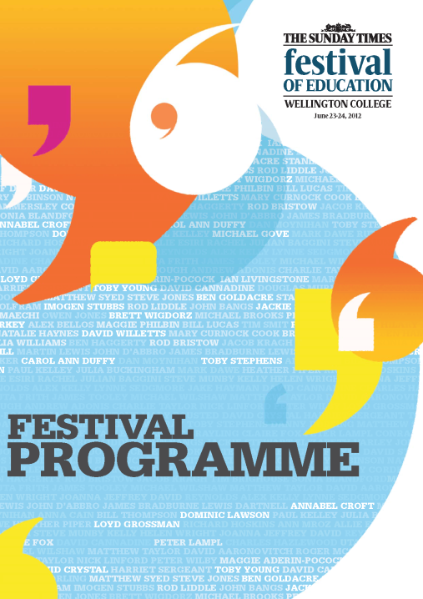
and at The Sunday Times Ed Fest

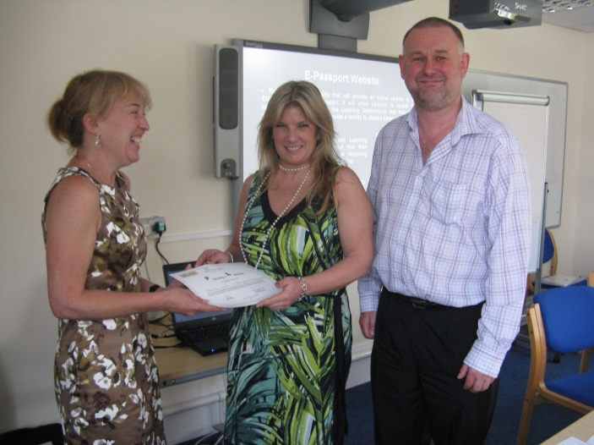
July 2012: the 1,000th CU Validator Natalie Hyman (centre)

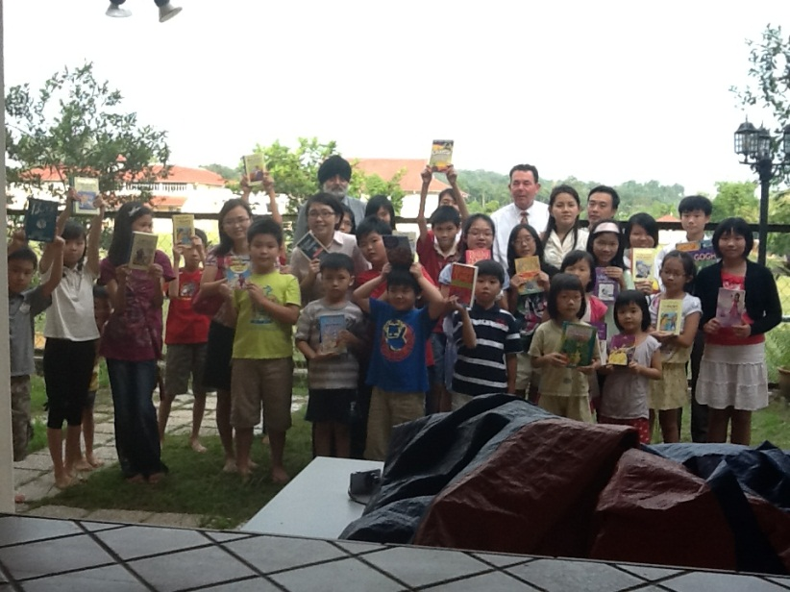
and CU Malaysia takes a (slow) step in the right direction

August 2012: just another August really…NOT!

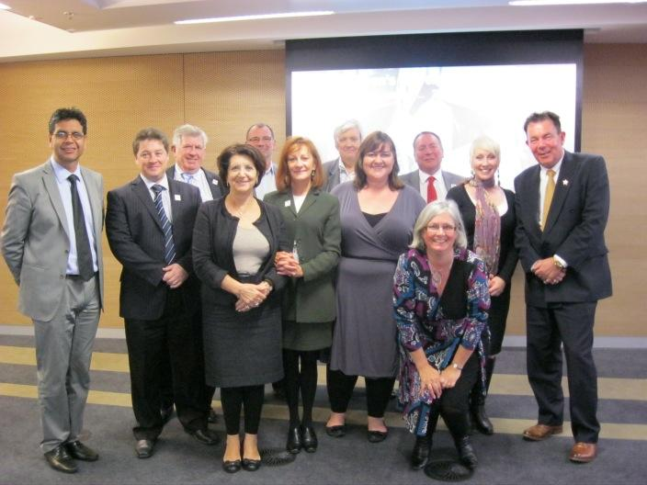
September 2012: the first CU Australia meeting..! Keith is wearing the red tie!

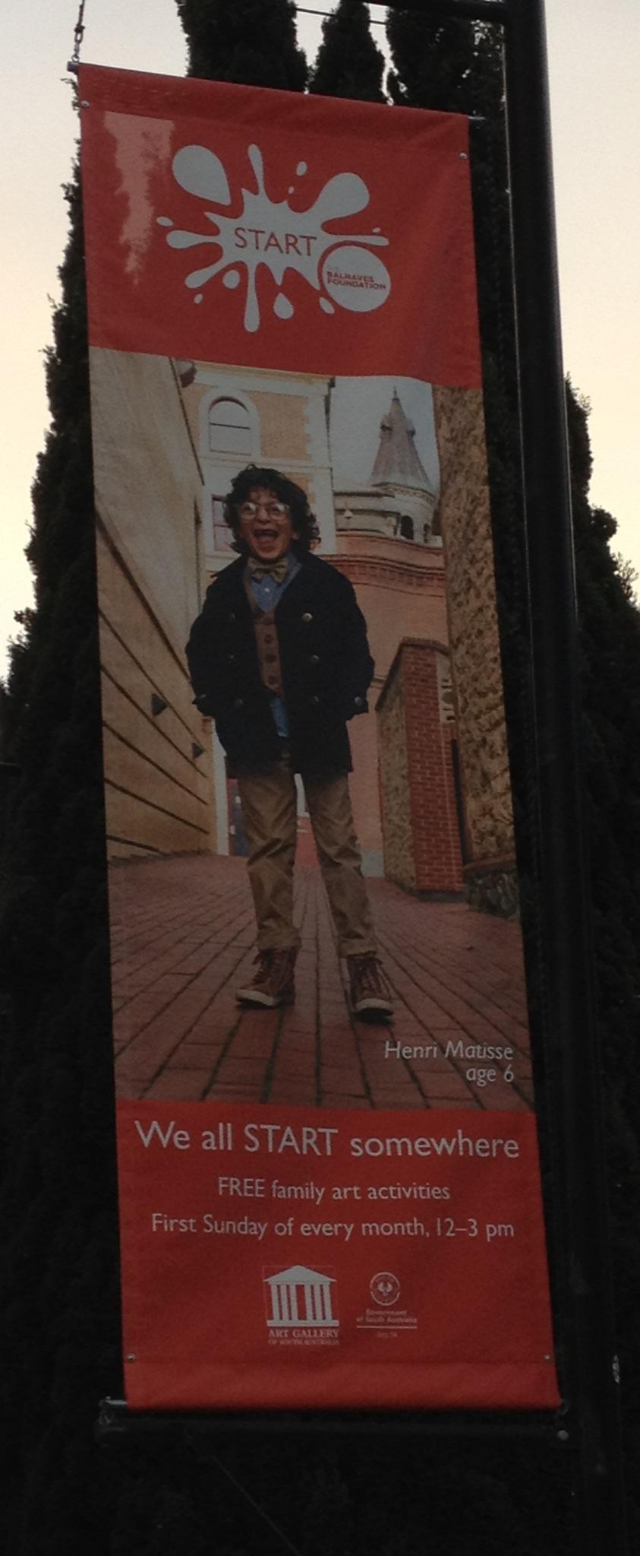
and guess what Henri gets up to on a Sunday …

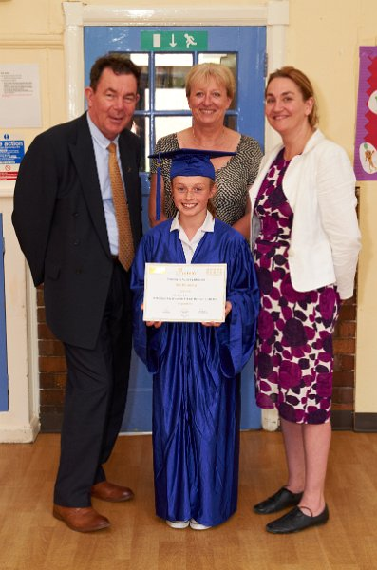
and Lauren Hill, the first CU Fellow… and a few grown-ups too
(including Headteacher Janet Baxter and local MP Natascha Engel)

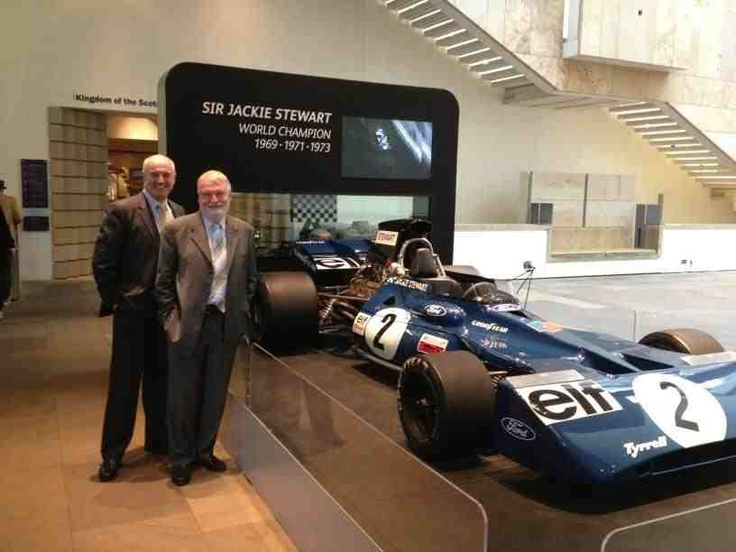
October 2012: roll on CU Scotland (with Jock and John)

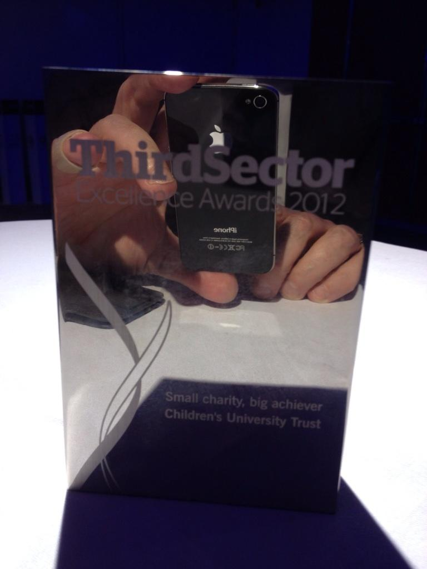
November 2012: and we won again …!

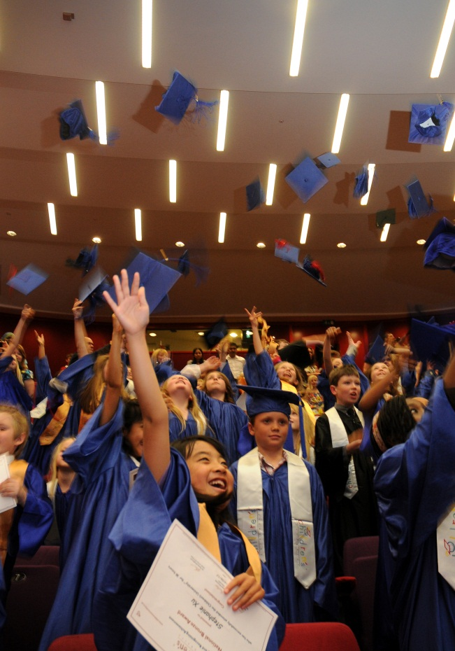
and we graduated again …

December 2012 again: we won more …!

Picture of the year …? No-brainer of the year!! Rebecca of course … still dancing of course!!

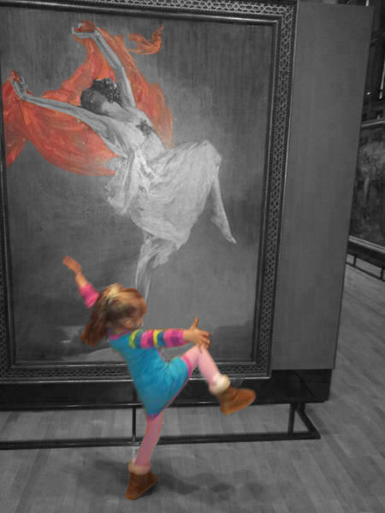

Have a good’n and TTFN!

