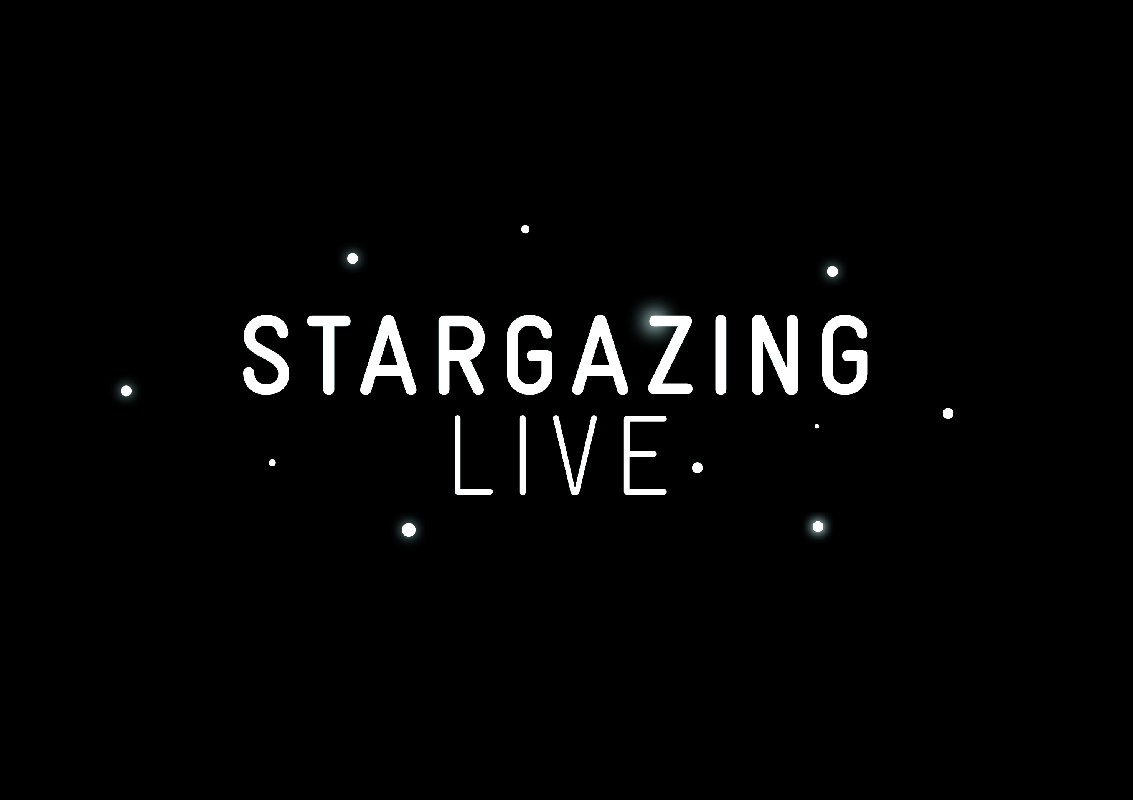

LEARNING DESTINATIONS AT JANUARY 2013 EVENTS

Yorkshire - Thurs 10th January – 5.30pm-9pm

YORKSHIRE MUSEUM
www.yorkshiremuseum.org.uk

ACTIVITIES INCLUDE:
- Tour the night sky across the world and hear a talk by an Astronomy expert.
- Sample space food, make a comet and try space suits.
- Discover the best places to view the stars in the Yorkshire region.
- Learn about the ancient way of navigating the stars and how this can be applied now.
- Make a space rover and star scene (creative activity for under 10’s).

As well as simple science experiments, planetariums, telescopes and observatory!

Northern Ireland – Thurs 10th January – 6-10pm

LOUGH NEAGH
www.discoverloughneagh.com/

ACTIVITIES INCLUDE:
- Take a night-time star cruise on the lake with a pre-recorded star talk or live guide.
- Get your hands dirty by handling some meteorites and moon rock.
- Learn about astronomy careers with a Supernova researcher from Queens.
- Learn about the life of a star with Ghastly Galaxies.
- Mars caricature artist.

As well as science shows from Big Bang, a star dome, link to Faulkes telescope and rocket making workshops.

Scotland – Wednesday 9th January – 4.30 – 9pm

KIBBLE PALACE and BOTANIC GARDENS
www.glasgowbotanicgardens.com

ACTIVITIES INCLUDE:
- Leave Earth behind with rocket workshops and activities on orbital dynamics.
- Create your own small and micro spacecraft systems.
- Build your own mini robots.
- Learn about the Magic of the Stars at a Supernova presentation.
- Join interactive talks and workshops.

As well as telescopes and binoculars, rock formation displays and a chois singing space themed songs.

Berkshire – Wednesday 9th January – 6 – 9pm

NEWBURY RACECOURSE
www.racecoursenewbury.co.uk/

ACTIVITIES INCLUDE:
- Take a ride on a G-force thrill ride.
- Listen to an educational talk from experts.
- Dress up as an atstronaut.
- Sample some space food.
- Get your hands dirty handling moon rocks.

As well as free Starguides, telescopes and demonstations, kids space music disco and facepainting.

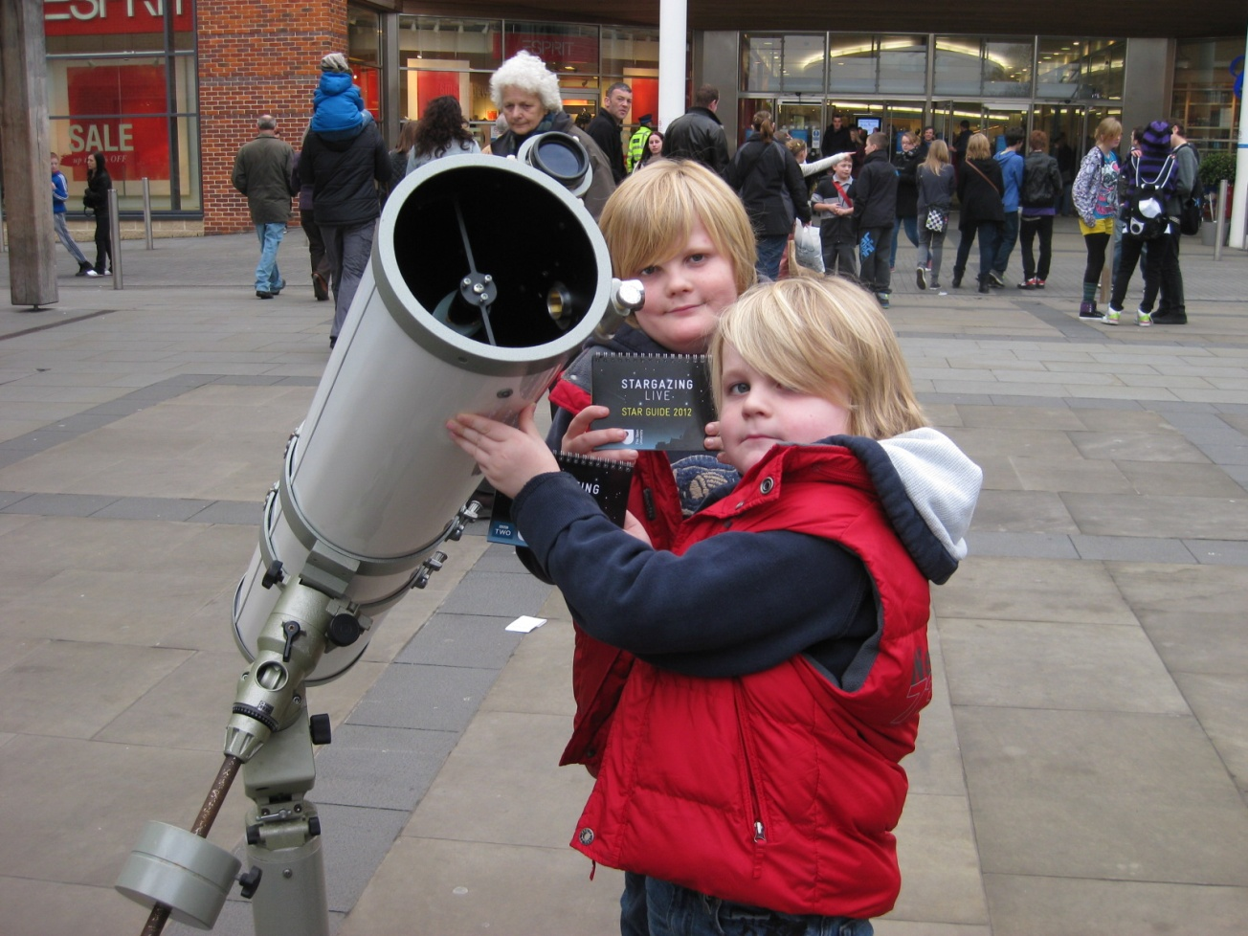

Go to www.bbc.co.uk/stargazing to find out about other events.

