Missed it …

The New Year’s resolution was a blog every month … so that’s that one gone – just! It is now March and because we blinked a few times February seems to have just disappeared. The fact that life has been pretty much completely mad busy might also have something to do with this of course …!
The House of Lords reception in honour of our 5th birthday was immense … nearly 200 people braved the weather (and how this country does not cope with it) and attended our reception hosted by our Patron Lord Lingfield. And they came from all over the globe: Australia, Singapore, Malaysia, Portugal, the Netherlands, Italy, Germany and from across the whole of the British Isles of course! For a trip down memory lane a click here will get you there (courtesy of DRB Birmingham)!!

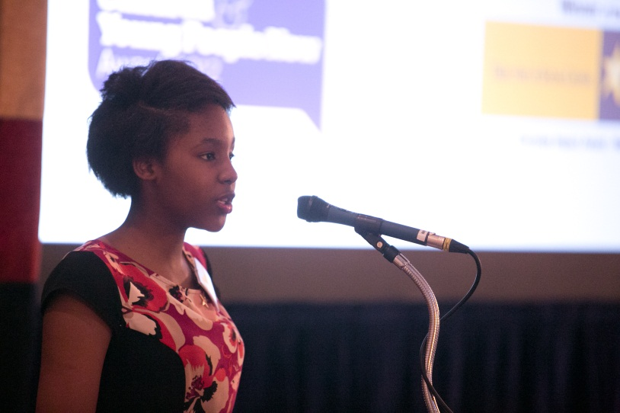
Sile Sibanda from Rotherham CU out-speaks the lot!!

Within a month of the House of Lords reception another event: the launch of the Northern Ireland Children’s University at Stormont on 19 February! The CU Trust Northern Ireland is a separate charity from the CU Trust and manages the Children’s University in Northern Ireland on our behalf – Keith Wysner is its chair and dynamo … I also received the best badge ever at the NI CU launch as you will see …

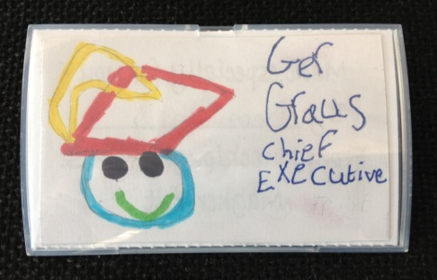
The best badge ever …

In the meantime, CU Australia and CU Scotland are beginning to stand on their own two feet with graduation dates set for late 2013 in both cases. CU Isle of Man will have its first graduation on 23rd April at St German’s Cathedral Peel. Singapore and Malaysia CUs are now also not far off their official start – April 2013-ish springs to mind!
New Forrest and Southampton are the latest CU areas to welcome to the ‘club’. The local Children’s Universities are managed by schools’ collaboratives in partnership with Brockenhurst College and Southampton Solvent University. The partnership will also be taking the Havant Children’s University under its wings! East Lancashire CU is also not too far off the mark and meetings with headteachers are in the diary. Meanwhile, a number of local CUs are looking to transform their management arrangements including Oxford and Oxfordshire … they are only following the example of many before them such as Warwickshire and Coventry, Nottingham and Nottinghamshire, Liverpool and the Wirral and Sefton of course – new times, new ways of doing things!!
Learning partnerships are continually developing and the BBC in Salford, Salford University and the Football League Trust are just a few names to mention. Lynne Upton, our Director of Learning will soon be in touch with a learning news update …!

Dr Anita Bhalla Jock Brown

At the CU Trust we have two new Trustees in Dr Anita Bhalla and Jock Brown; details can be found here http://www.childrensuniversity.co.uk/about-us/who-we-are/meet-the-trustees/.
Thanks to the support from the Esmée Fairbairn Foundation we are able to advertise for the position of Head of Local CU Support and Development for a two year period initially. The post will enable new local CUs to be conceived and born much easier and it will also allow existing CU centres to grow … the post will be advertised in the TES online on 15th March and we of course also contact all local Children’s Universities with the information – so watch this space!!

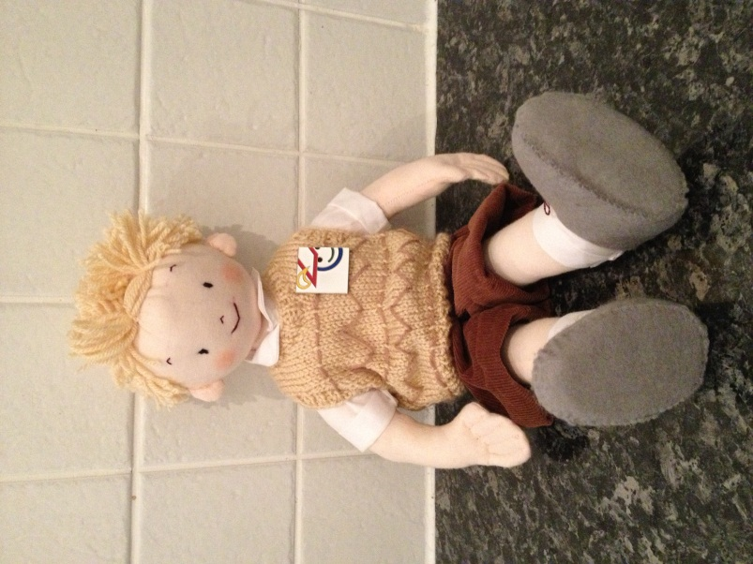
Please meet … Alfie Tate

Alfie Tate is a Copper Tree kid and he features in Hilary Robinson’s The Copper Tree series http://www.hilaryrobinson.co.uk/genre/the-copper-tree-class/. Alfie’s birthday is on 22nd March and apparently he was born in Holland; when he was adopted he moved to Shrigley in England. Alfie is a member of The Copper Tree class at Woodpecker Primary School. Alfie now has his own CU passport and badge and will be coming to a place near you … very soon! One of Alfie’s key tasks is also to make me write my blogs on time.

So … TTFN and see you soon!

