Northamptonshire CU teams up with the University of Northampton for a fabulous film project!

Northamptonshire CU teamed up with students and staff from the University of Northampton, Media department to run a four week, after school project at Kingsthorpe Grove Primary School.

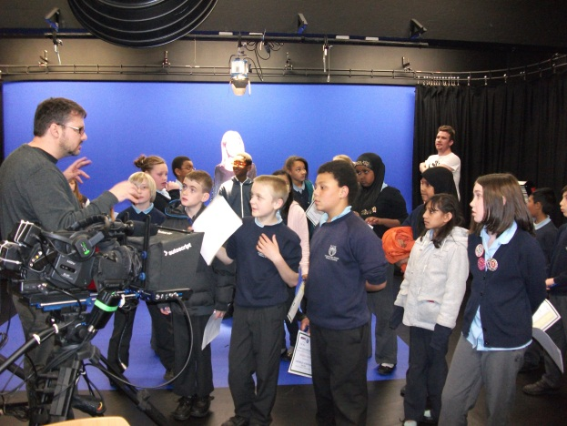

Lecturer, Tim Coley invited Nikki Taylor, Northamptonshire CU, to address undergraduates studying Film and Media offering them a chance to create a short film about the CU as part of their course work. Students from the University’s media course were invited to create a short viral to advertise Northamptonshire Children’s University. Nikki Taylor from Northamptonshire CU visited one of the undergraduate sessions and did a brief presentation about the CU. The students were encouraged to be creative with their ideas if they wished to pursue the CU as a theme for their project. One group came and filmed a Children’s University graduation ceremony that was held at the University of Northampton in December. Three other students proposed a short film.

The three students, Christopher Griffiths, Danny Bull and Georgina Chapman, created a storyboard and contacted Nikki to ask for her help in finding some students to be filmed. After a discussion, it was agreed that the way forward would be to create a four week after school club for a local primary school. We would offer the chance for the young people to be part of the film but also to learn some basic film techniques.

Kingsthorpe Grove Primary school kindly agreed to support this club. The club was set up as a Children’s University activity run by Nikki Taylor, as the CU representative and the undergraduate students. The KGPS Film-making Club ran for four weeks for one hour after school with twenty year 5 and 6 students participating. The activity was CU validated and all the students earned CU credits for their participation. They examined the storyboard created by the undergraduates and offered alternative suggestions. They learnt about the equipment being used and participated in drama games. The result was short film about the Children’s University.

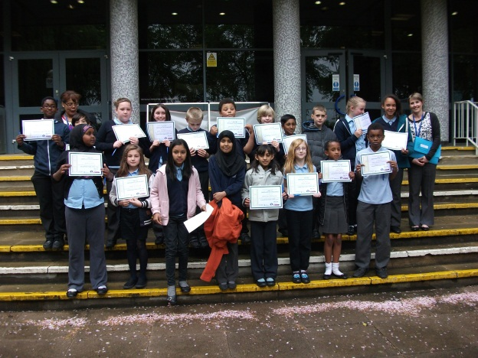

The University students then submitted the footage as part of their course work.

On Thursday 23rd May 2013 at 2pm at Avenue Campus, school staff, parents and the children were invited to the University for a very special screening of their work. The University played host giving the students a tour and detailed information about the opportunities on offer for the young budding stars and film-makers.

Senior Lecturer Tim Coley said ‘This has been a win-win partnership; for the students who were able to work to a live brief, to the children of Kingsthorpe Grove Primary who were able to appear in the viral and later attend the film screening, and to the Children’s University who acted as the conduit. The first hopefully of many more successful partnerships.’

For more info on CU in Northamptonshire, please contact Nikki Taylor, Project Development Officer (Children's University, Student Leadership & Volunteering):

Tel: 01604 367 718
Email: NKTaylor@northamptonshire.gov.uk

