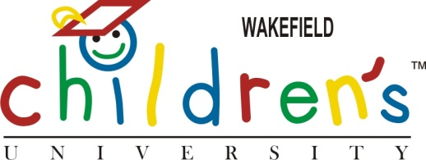

Wakefield CU Graduation – July 2013

Wakefield CU graduates!

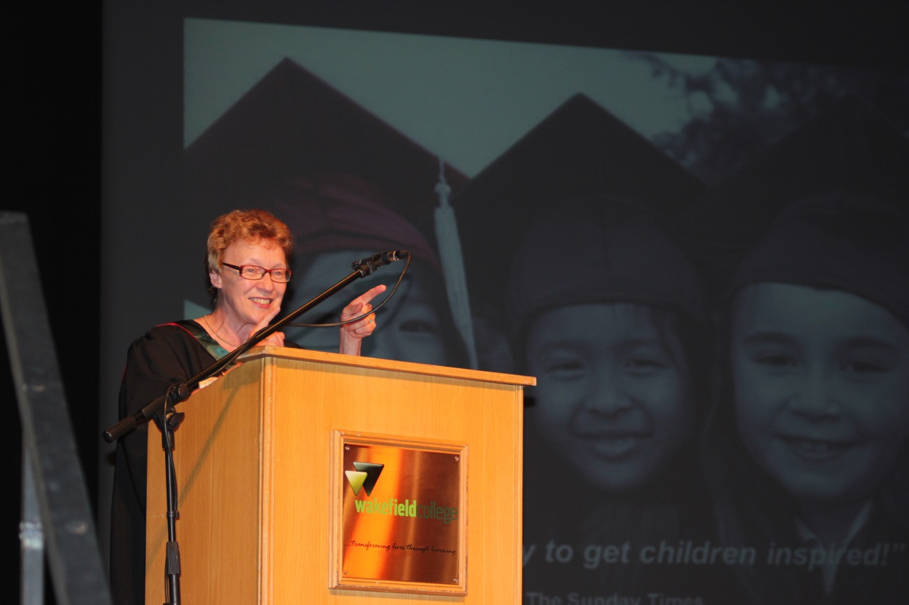
Lynne Upton, Director of Learning, Children’s University

