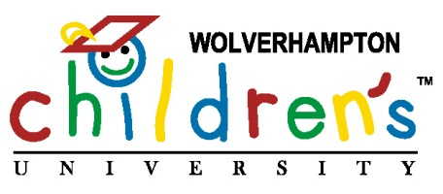

PUPILS GRADUATE FROM CHILDREN’S UNIVERSITY

Pupils from Manor Primary School in Wolverhampton donned mortar boards and gowns as they ‘graduated’ from Wolverhampton’s Children’s University on Tuesday 16th July 2013.

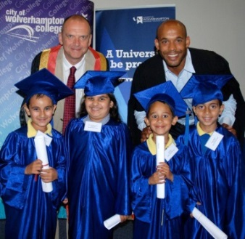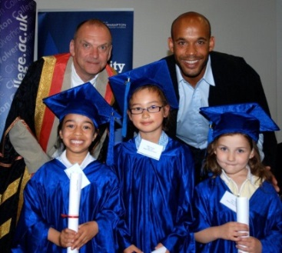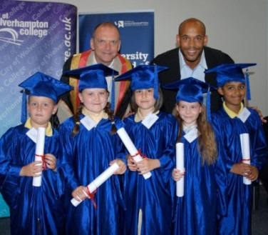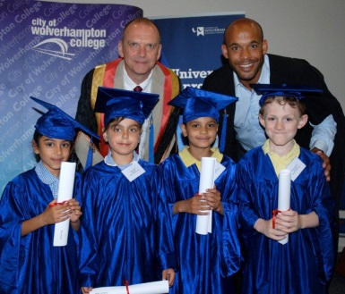

The national Children’s University scheme encourages youngsters to get involved in out-of-school clubs and activities and record their participation in a learning ‘passport’. Once they have accumulated enough points in their passport they are presented with a certificate of achievement at a graduation ceremony.

Around 180 pupils, aged 6 to 11, who have taken part in a range of extra-curricular activities - including cooking, sport and homework clubs - attended the ceremony at the University of Wolverhampton and received certificates from former Wolves goalkeeper Matt Murray who is Chancellor of the city’s Children’s University, Professor Geoff Layer, Vice Chancellor of the University of Wolverhampton, and Lynne Upton, Director of Learning of the National Children’s University.

The scheme was launched in the city in May 2012 - with 20 pupils from Manor Primary School graduating last July - and has been led by City of Wolverhampton College in partnership with the City Council and the University.

Mark Robertson, Principal of the College, said: “The College is delighted to be part of this wonderful programme. Our young people are the future and I am confident that the children will go on to have great success in their lives and to benefit in their learning and careers from being part of the Children’s University.”

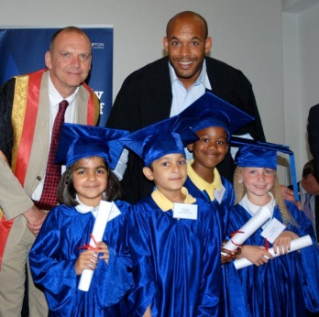 | 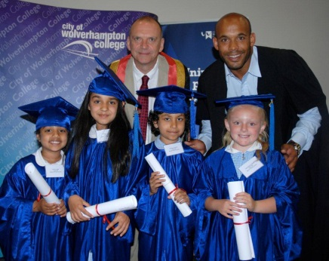 | 