English Heritage properties to become Children’s University ‘Learning Destinations’

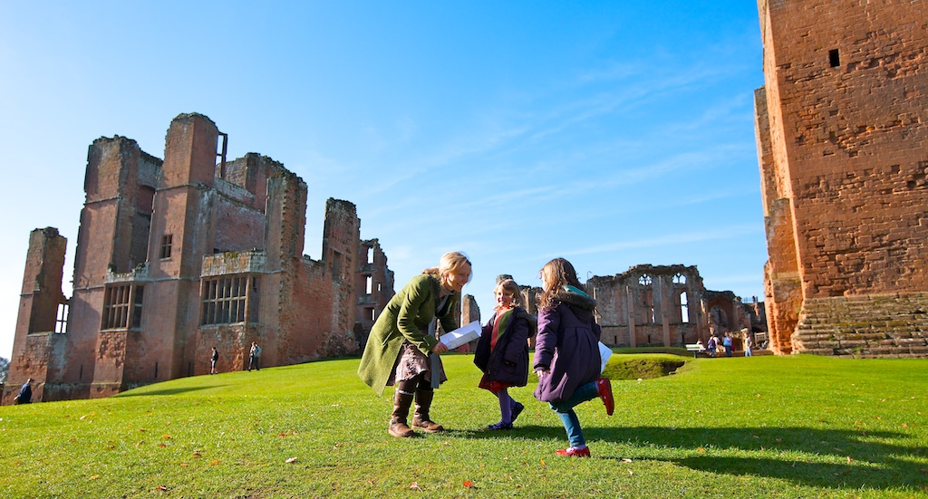

Children’s University is delighted to announce a formal partnership with English Heritage to encourage more young people and their families to enjoy visits to Stonehenge, Dover Castle, Kenilworth Castle, Whitby Abbey and the other properties in English Heritage’s care while at the same time contributing to their children’s university awards. Some English Heritage properties already participate very successfully in the scheme and we are pleased to be able to extend this nationwide.

The Children’s University is an international charity that provides 7-14 year olds (and 5 and 6 year olds with their families and carers) with exciting, high quality learning experiences outside the normal school day. It aims to raise children’s aspirations and develop a love of learning by issuing children with a ‘Passport To Learning’ which records their individual learning journey. From (insert date) children will be able to get their passports stamped when they visit any English Heritage Property for the first time, and receive further recognition if they take part in some of the many exciting activities offered at individual sites.

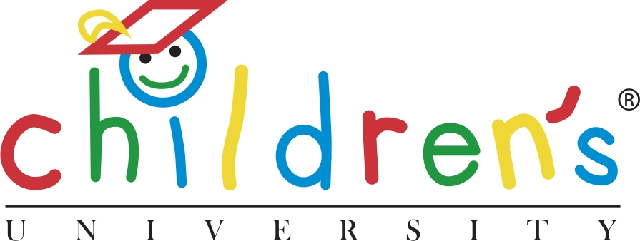

Ger Graus, Chief Executive of the Children’s University says: “We aim to raise children’s aspirations to learning and setting their personal goals – asking questions about how things were in the past is a good basis for thinking about how things could develop in the future.

This partnership with English Heritage will offer children and their families a fun way of spending time together in settings which can spark their curiosity and fuel their imagination.

Sandra Stancliffe, Head of Education for English Heritage says: “This exciting partnership between English Heritage and the Children’s University is perfect for ensuring that as many children as possible engage with the historic environment. Students of the Children’s University will now be able to immerse themselves in The Story of England, contribute huge amounts to their learning and of course move them towards Graduation.”
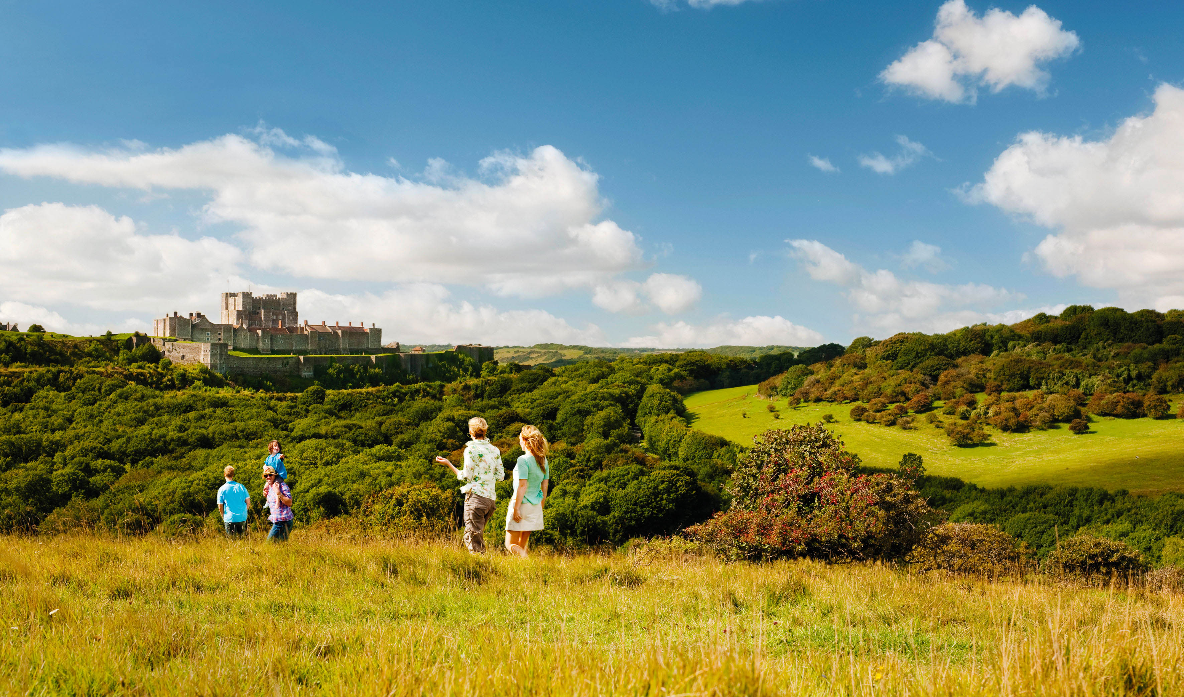

Currently over 3.000 schools and academies participate in the Children’s University and there are over 2.000 public ‘Learning Destinations’ including museums, galleries and libraries as well as discovery centres, outdoor learning opportunities, sports facilities, performing arts centres and a whole range of youth groups.

Media contacts:

English Heritage Michael Murray-Fennell, English Heritage Communications, michael.murray-fennell@english-heritage.org.uk
Children’s University - Lynne Upton, Director of Learning, Children’s University:
lynne.upton@childrensuniversity.co.uk

Notes to editors:

^{1 –} For the bronze level certificate, children need to do 30 hours of learning, 65 hours for silver and 100 hours for gold.
Children’s University is run by the Children’s University (CU) Trust. For more information visit: www.childrensuniversity.co.uk

English Heritage is the custodian of over 400 historic monuments, buildings and sites through which we bring the story of England to life for over 10 million visitors each year.
www.english-heritage.org.uk

