‘Thanks again and I hope you enjoyed the conference - we all found it riveting and a privilege to be part of such a fantastic organisation.’ Hilary Robinson

‘Thank you for such an excellent conference, every part of it was 10 out of 10. It has re-inspired me and I have received very positive feedback from others who attended too.’ Carolyn Lloyd

‘Good Afternoon my Friend… First & foremost, a huge thank you for the honour and privilege of being invited to speak yesterday. I loved being there and meeting all of the interesting folk. All very best.’ JC

‘I was delighted to be able to attend. Thank you for the kind invitation and opportunity. Working with CU has been a pleasure and each reminder of what we aim to achieve for ‘the children’, never fails to tap into the emotional side of my life. I hope you and your family have peaceful Christmas and Happy New Year. Kind regards.’ Doug Wilson

‘I just wanted to thank all of you for the magnificent 6th annual CU conference. It was a wonderful learning opportunity for me and a great experience all round. The speakers were insightful, varied and above all, all about the children. There really was something for everyone. I cannot begin to imagine the work you all put in to make the event as special as it was but we all really appreciate your hard work, enthusiasm and dedication. Here’s to number 7!’ Emma Jenkins

‘May I take this opportunity to thank you and all the National CU staff for what was, again, an amazing and inspirational conference. Thanks to the guest speakers and the workshop deliverers as well. Look forward to the next already, (not sure you all will be just yet!).’ Suzy Chapman

‘Something of a triumph for you and the team yet again, with great prospects for the future. Well done and thanks to everyone.’ Sir David Winkley

‘A pleasure and reinforced my commitment to the CU. Best Wishes.’ Richard Annandale

‘Just a big ‘thanks’ and ‘well done’ on such a wonderful conference – as always a fantastic event and one of the highlights of the academic year! From the children singing to Gervase’s anecdotes and meeting old friends and new colleagues – thoroughly enjoyable! The workshops were really relevant and will help us as we plan for the year ahead. Thanks again.’ James Pennington

‘Thanks so much for inviting me. I was honoured.’ Jay Griffiths

‘Many thanks for a wonderful conference. Each year I get to meet and know more people and it is quickly becoming a reunion of friends!’ Hilary Robinson

‘I wish to thank you and the whole team for the brilliant outcome of all your efforts and creativity. Happy Christmas to all.’ Dr J Sandy Bradbrook

‘Many, many congratulations on a wonderful CU Conference. A very good job done! I enjoyed everything about it and it has set me up for the year ahead. Thank you to you both and others in the team!!! Very best wishes.’ Carolyn Lloyd

‘A real pleasure, Ger – an excellent event.’ Jock Brown

‘Please pass on my thanks to everyone involved in organising the CU Conference this week. Many thanks to you all for your help and support throughout the year and best wishes for Christmas and 2014.’ Enid Harrison

‘It was a real privilege to be invited to be part of such a prestigious event. I am very happy as part of your CU family and excited as to where the future can take us all. Once again, many thanks. Kind regards.’ Emma Jenkins

‘This was the first conference I have personally been to in a couple of years and I think the best one I have attended to date. The event just seems to get bigger and more inspiring (not to mention helpful) every year. Please pass on our thanks Ger and the whole team for the continued support and efforts, we are really excited about the future of our CU(s) and equally enthused by the success stories all over the world.’ Matthew Vaudrey

‘Our pleasure, kids loved it and yes am very proud of them all. Best wishes to you and the team for Christmas and the new year.’ Jill Robertson

‘Thanks for this. The Children's University continues to inspire, which is grand. Meet up soon one way or another, I hope.’ Michael Morpurgo

‘Thank you to everyone @CU_Trust & all the delegates for making my 1st #CUannualconference2013 a great one, here's to many more!’ Dr Patricia Sterpaio‏@STEMAbertay

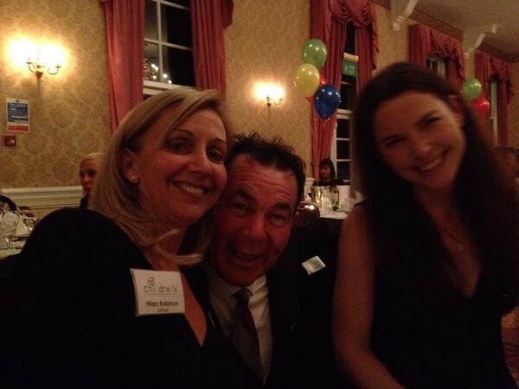
‘Feeling inspired after the #CUannualconference2013’ Emma Good‏@Emsielu

‘Happy memories from #CUannualconference2013’ EssexCU‏@Tendring

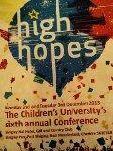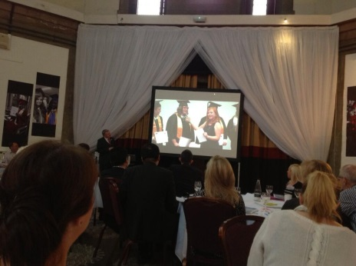
‘Inspiring 2 days spent #CUannualconference2013 with fellow CU colleagues and guests from across the UK and the globe!’ Childrens University‏@WarwickshireCU

‘Wonderful response to #alicelovesculovesalice by @Madi_Tricker. I feel like a star! #CUannualconference2013’ EssexCU‏@Tendring

‘Thanks to CU_Trust & all the delegates for making my 1st #CUannualconference2013 a great one, hope it's the first of many’ Aileen Wilson‏@Aileen_Wilson

‘I'm back!!! Watch out TESSmanians, I am feeling all super charged and up beat after #CUannualconference2013’ Assoc Vice Principal‏@NadineMcFadden1

‘Great #CUannualconference2013. So proud of presentation of Tendring campus by @schamberlaincca Thanks for the lift too- it was an education!’ EssexCU‏@Tendring

‘Almost home ... 35 minutes til Dundee. Thanks @CU_Trust for a fantastic #CUannualconference2013’ Dr Patricia Sterpaio‏@STEMAbertay

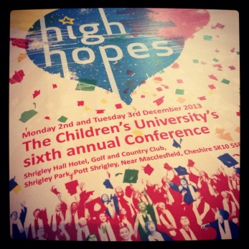
‘Thank you @CU_Trust @CU_Development @CU_Learning for making the #CUannualconference2013 so poignant and informative’ Kent CU‏@K_C_U2

‘Super @alicepaigecx celebrated by @schamberlaincca #CUannualconference2013 Very proud of all involved.’ EssexCU‏@Tendring

‘#CUannualconference2013 sad to be over but some awesome plans for the future :-)’ Richard Machin‏@richardmachin11

‘sorry to say goodbye to so many friends #CUannualconference2013 the best conference to date ... bring on no7’ Lesley Stout‏@LesleyStout

‘Excellent presentation from Stephen Chamberlain with the most moving video of Alice. #CUannualconference2013’ Aileen Wilson‏@Aileen_Wilson

‘@schamberlaincca fab speech Stephen at #CUannualconference2013. Where's the Kleenex?’ Lisa Strutt‏@lstrutt

‘@Madi_Tricker thanks for your fantastic video about CU at #CUannualconference2013. Very powerful!’ Lisa Strutt‏@lstrutt
‘#CUannualconference2013 Bringing up #Confident Children, with #Confident minds....Brilliant!!’
Michael Babu‏@Babu_Michael

‘#CUannualConference2013 great speech by Keith Bartley...inspiring to see people with vast experience, know there is alot to learn from kids’ Michael Babu‏@Babu_Michael

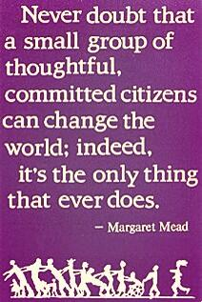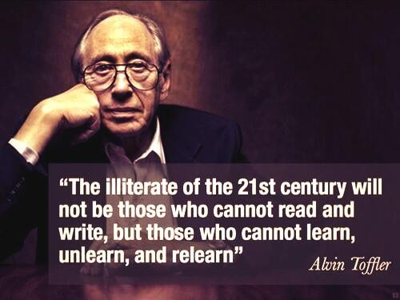
‘Ger @CU_Trust is showing us his vision for our way forward,as innovative leaders of learning #CUannualconference2013’ Kent CU‏@K_C_U
‘@KeithbrtlyKeith encapsulates why all involved with @CU_Trust strive to move forward #CUannualconference2013’ Kent CU‏@K_C_U

‘Children's University - a charity at heart with a business mindset, Ger Graus #CUannualconference2013’ Lisa Strutt‏@lstrutt

‘A very interesting & inspiring couple of days at #CUannualconference2013 Great job folks!’ Gillian Hastings‏@gillianhastings

‘Looking forward to another whirlwind of inspiration, ideas and indigestion if they keep overfeeding us! #CUannualconference2013’ Aileen Wilson‏@Aileen_Wilson

‘SheffieldCU proving the impact of the CU at the #CUannualconference2013. Fantastic work in schools in NE Sheffield. Good workshop‘ Keith Bartley‏@KeithbrtlyKeith

‘looking forward to day 2 #CUannualconference2013 so many good ideas to share when I get back to the ranch!!’ Lesley Stout‏@LesleyStout

‘Fab night with Gervais Phinn at our table & our after dinner speaker. Thought provoking & funny in equal measures. #CUannualconference2013’ Aileen Wilson‏@Aileen_Wilson

‘Fantastic day at the #CUannualconference2013 delivering our workshop and listening to fabulous Gervase Phinn. Here's to day 2!’ Sheffield CU‏@SheffieldCU

‘big thanks to everyone who has worked so hard to make CU's 6th Annual Conference brilliant #cuannualconference2013’ Croydon CU‏@CroydonCU

‘Looking forward to listening to Gervase Phinn at the #CUannualconference2013 dinner this evening’ Oldham CU‏@OldhamCU
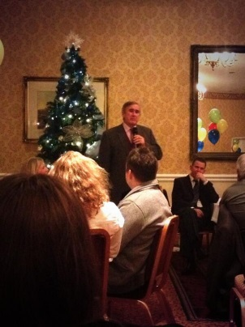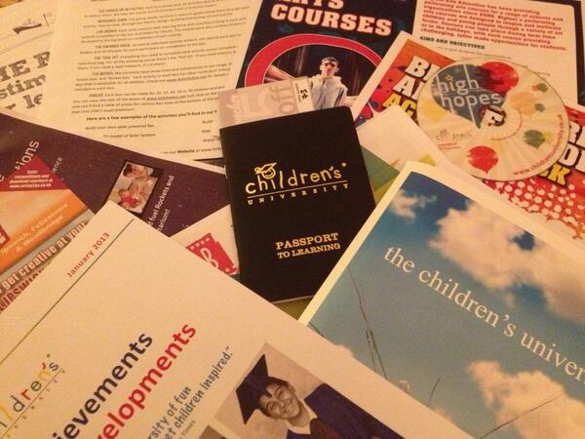
‘Look at all my lovelies goodies. Lots of ideas to take back to Essex #CUannualconference2013’ EssexCU‏@Tendring
‘Thank you Gervase Phinn for bringing back happy memories associated with life in a school! #CUannualconference2013’ Kent CU‏@K_C_U2

‘Great first afternoon. I'm now Inspired, enthused & just a tad daunted, wonder what will come next? #CUannualconference2013’Aileen Wilson‏@Aileen_Wilson

‘@lstrutt: Thanks to Caroline Gilbert @CU_Trust for link to @fundingcentral. Useful for making links with funders. #CUannualconference2013’ Childrens University‏@CU_Development

‘@hbkfw: thank you Debbie and Emma for social media ideas #CUannualconference2013’ Childrens University‏@CU_Development

‘@mysongofsongs @HarpfieldST4 @CU_Trust As always, a very emotional part of the #CUannualconference2013’ Kent CU‏@K_C_U

‘Brilliant first day so far looking forward to the rest! #CUannualconference2013’ sarah‏@buttonmoon72

‘Important and useful workshops today at #CUannualconference2013 delivered by @CU_Development @K_C_U @CU_Trust @SheffieldCU’ Oldham CU‏@OldhamCU

‘#CUannualconference2013 definitely looking forward to start and have a programme of great influence back in Kenya...#Brilliant’ Michael Babu‏@Babu_Michael

‘#CUannualconference2013 A brilliant First day in #Macclesfield.. great organization and empowering content...loving the sessions and order’ Michael Babu‏@Babu_Michael

‘#CUannualconference2013 Excellent so far - great workshop from Kent CU’ Jayne Basnett‏@Jaybazzie

‘Enjoying #CUannualconference2013 - great ideas to take back! Great workshops by @K_C_U @CU_Trust @CU_Development @SheffieldCU’ Sefton Childrens Uni‏@SeftonCU

‘#CUannualconference2013 The Future of Opportunity for our Children gets better and better :-)’ Richard Machin‏@richardmachin11

‘Excellent workshops today & inspiring talks @CU_Trust #CUannualconference2013’ Dr Patricia Sterpaio‏@STEMAbertay

‘Great social media master class by Emma from @K_C_U at #CUannualconference2013 Lots of ideas to come back with!’ York CU‏@CUYork

‘At the #CUannualconference2013. Inspired already and it's only hour 3! Thanks @K_C_U Manager Emma Jenkins for Social Media Think&Do shop’ Lisa Strutt‏@lstrutt

‘thank you Debbie and Emma for social media ideas #CUannualconference2013’ Heather Beach‏@hbkfw2 Dec

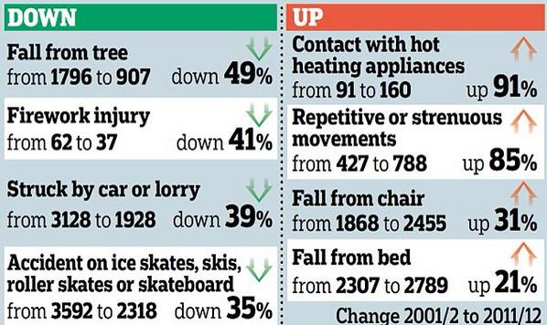
‘Wonderful Keynote speech from author Jay Griffiths . How alarming are these statistics! #CUannualconference2013 pic.twitter.com/mnRrAdhi2F’ Kent CU‏@K_C_U

