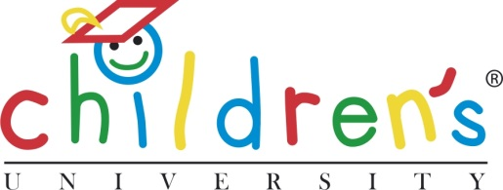

Inspirational Journeys: Land’s End to John O’Groats Cycling Challenge

Neil Bradbrook – son of CU Trust Chair, Sandy Bradbrook – has set himself the challenge of cycling from Land’s End to John O’Groats (approximately 1000 miles) in just 11 days. Neil is cycling in support of the Children’s University and to raise awareness and encourage young people to take up cycling and of course to cycle safely.

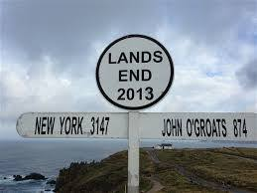

To find out more about Neil’s adventure please visit his Facebook page at Facebook/LEJOG2014Neil, follow him through Twitter @NeilBradbrook or pledge your support by donating at www.wishgenie.com/Neil_LEJOG

For further information, please contact:

Michelle Box
Project Administrator - Children’s University
michelle.box@childrensuniversity.co.uk
0161 907 5389 (Monday to Friday 08:30 – 17:00)

Notes to editors:

The Children's University is an (inter)national organisation that provides 7 to 14 year olds (and 5 and 6 year olds with their families) with exciting and innovative learning activities and experiences outside normal school hours. We celebrate achievement and reward participation through our certificates.
Raising children's aspirations is important to us and we aim to develop the understanding that learning can be 'a satellite navigation to better places in life'. The ethos of the Children's University is one of cooperation, collaboration, learning from each other and making things better for children and young people irrespective of their background. Independent evaluation by the University of Cambridge has confirmed that participation in Children’s University significantly improves school attendance, increases levels of attainment (across all subject areas) and raises aspirations. It also builds confidence and embeds/nurtures critical life skills such as the ability to work as part of team, effective communication, resilience, and initiative – attributes which will be highly prized by future employers. For more details on the CU please log onto: www.childrensuniversity.co.uk.

