Six-year-old Sam sets up military museum in his bedroom
David Bale
Friday, February 28, 2014 12:16 PM

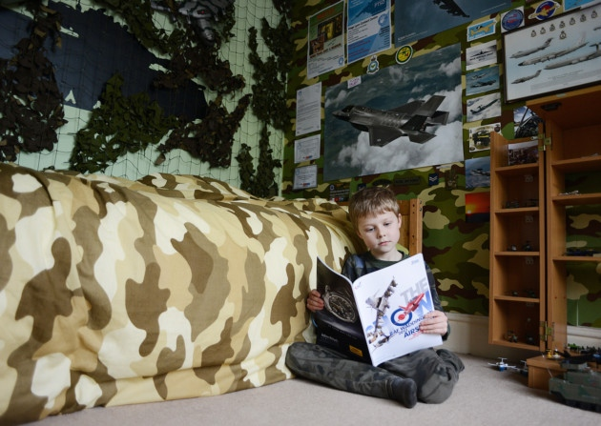
Samuel Boore (6) has turned his bedroom into a military museum. Picture: Ian Burt Samuel Boore (6) has turned his bedroom into a military museum. Picture: Ian Burt

Most six-year-old boys’ bedrooms have pictures of footballers, Thomas the Tank Engine, or Ninja turtles on the walls. But Sam Boore has set up a military museum in his bedroom – and he’s charging people to visit in aid of the armed forces charity, the Bridge For Heroes.

Sam’s parents say the youngster was a quiet boy who wasn’t interested in reading until he visited the aviation heritage centre at RAF Marham. He was so impressed that he decided he wanted his own museum.

So he turned his bedroom into a military museum with model aeroplanes and camouflage netting decorating the walls.

His bedroom is filled with books on the military, toys, paintings, drawings, a map from the Second World War, and artefacts he has been given – and he even has military-style pyjamas. He has collected so much to show off that he had to turf his parents out of their front bedroom to accommodate it all. He has also decided to raise money for charity so he charges entry to his museum – and has so far raised £50 for the Bridge for Heroes charity.

Dad Warren Boore, 49, said: “On the way back home from our first visit to the heritage centre, Sam said ‘I’m going to start a museum’. We all said, ‘All right Sam’, but he did.

“He found a few pictures in books that afternoon and was given a few posters at the centre.

“We bought a plane, a Hercules C130, which is on the wall, and camouflage netting.

“His sleeping bag was given to us by Geoff Hammond, a retired major who lives in Watlington. He also got a major rank slide pin.

“One of the framed prints on his wall is from RAF Waddington in Lincolnshire, and squaddies from Hereford have also been helping Sam with his collection. The second time we went to the centre they gave him a couple more models and photographs.

“When a plane goes overhead he can tell what type it is from the noise.”

Not surprisingly, Sam, from Stow Road, Magdalen, near King’s Lynn, wants to be a pilot when he grows up. His parents believe that part of the attraction may lie in the boy’s ancestry. His grandfather Peter Boore, who lived at Gayton, was in the air force, and his great-uncle ‘Uncle Mac’ Boore, 80, who also lives in Magdalen, did his national service at RAF Marham in the 1950s.

Sam, who has a sister, Lucy, four, said: “When we went to RAF Marham I found it interesting and I started with a few pictures of aeroplanes. Other boys do other things: I collect planes.”

Mr Boore said Sam was previously a quiet boy, who would have “hid” in his room rather than talk to anyone. He added: “We took him to karate classes to improve his confidence. And since he went to the RAF museum his numeracy and literacy skills have improved. He’s amazed all of us with his knowledge.”

Mum Paula Boore, 37, a teaching assistant at Magdalen Village School, which her son attends, said: “Sam had not been that confident with reading at school, but when he went to the museum, he was standing and talking to the people who run it, and reading all the display boards.” Great-uncle ‘Uncle Mac’ said: “It’s getting to be quite expensive coming over here. Every time Sam says ‘come and see what I’ve got in my museum’ he rattles a donation box.”

Warrant officer Steve Roberts, the curator of the RAF Marham aviation heritage centre, said: “The Royal Air Force Marham Heritage Team is absolutely delighted that our collection should inspire Sam. His willingness to become involved in charity fundraising for the greater good at his age sets an example to us all.”

The Bridge for Heroes charity offers special rest and recuperation for our armed forces and veterans and their dependants. Visit www.thebridgeforheroes.org.

Video clip of Sam:

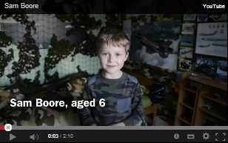

To see a clip about Sam, please go to the following link: https://www.youtube.com/watch?v=1CMXRaLVzpU or click on the above thumbnail.

Photo gallery:

