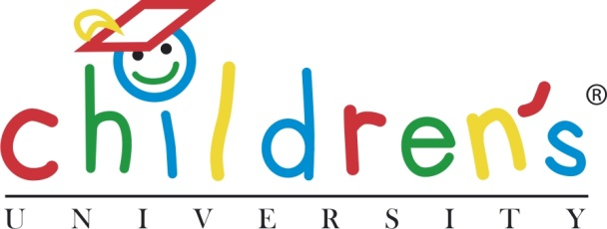

Children’s University Mission, Values, Aims and Policies

Mission

The CU Trust will foster the personal development of children through quality assured out-of-school-hours learning so as to contribute to their love of learning and enhance social mobility for all, through the local leadership within each CU engaging with a wide range of partners who wish to stimulate and contribute to the learning processes and skills, for children and young people.

Values

The CU Trust conducts its activities and takes decisions within the values that:

- Encourage voluntary participation by children and young people and voluntary contributions by adults and other partners
- Stimulate and support local leadership and partnerships
- All activities shall be of high quality and quality assured
- Learning shall be child directed as far as possible
- Reviews of effectiveness shall be independent and authoritative
- Each local CU centre shall be financially sustainable

Aims

The Children’s University aims to:

- Promote social mobility by providing high quality out-of-school-hours learning activities to children aged 5-14
- Target children and young people facing socio-economic disadvantage and in areas of deprivation
- Ensure that every child, irrespective of parental means, has access to quality out-of-school-hours learning activities
- Support young people to become confident, independent learners by encouraging engagement with learning
- Promote independent learning through voluntary participation and support young people to foster a love of learning
- Inspire and raise aspirations for children and their parents
- Enhance achievement and promote a variety of intelligences in the learning process
- Enhance participation in and of the wider community and provide an environment for children to make the most of their abilities and interests
- Promote the personal, social and emotional development and mental health, and to safeguard the well-being, of young people on its courses
- Monitor, record and accredit learners’ achievements, within the (inter)national CU framework

Principal Policy Areas

The principal policy areas that are used to fulfil these aims are:

- The Children’s University targets the 7-14 age range (and 5 and 6 year olds with their parents and carers) because this is a crucial stage for children in forming an attachment to personalised learning and aspiring to learn. Children are able to make choices about their learning, to move at different paces, to discover and pursue particular interests and the Children’s University supports them in all of these things.

- The Children’s University seeks to bridge the primary/secondary divide and to provide a continuity of learning that is highly valuable in this vulnerable transitional phase.

- The Children’s University fosters the ‘hard skills’ of educational accomplishment through course design and teaching arrangements that allow children to participate and progress at an appropriate level irrespective of age in appropriate subjects. CU activities contribute to raising standards in literacy and numeracy.

- Developing the ‘soft skills’ of making choices, growing in confidence, self-belief, learning how to get the best from oneself and for others, taking charge of one’s learning, and contributing to - as well as benefiting from - a learning community are essential to children’s levels of aspiration and engagement in learning. Participation in the Children’s University fosters such engagement and raises children’s aspiration.

- Participation in the expressive and creative arts makes a core contribution to children’s personal and social development and this informs all CU provision. The Children’s University actively promotes the development of arts based projects in its centres and in the communities they serve.

- The CU Trust will promote provision that supports the development of children’s well-being, as there is widespread concern with regard to the emotional well-being and mental health of the young.

