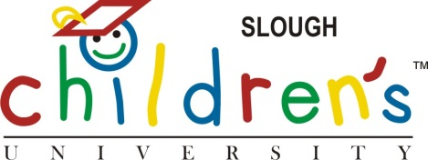

CU Graduation in Slough!

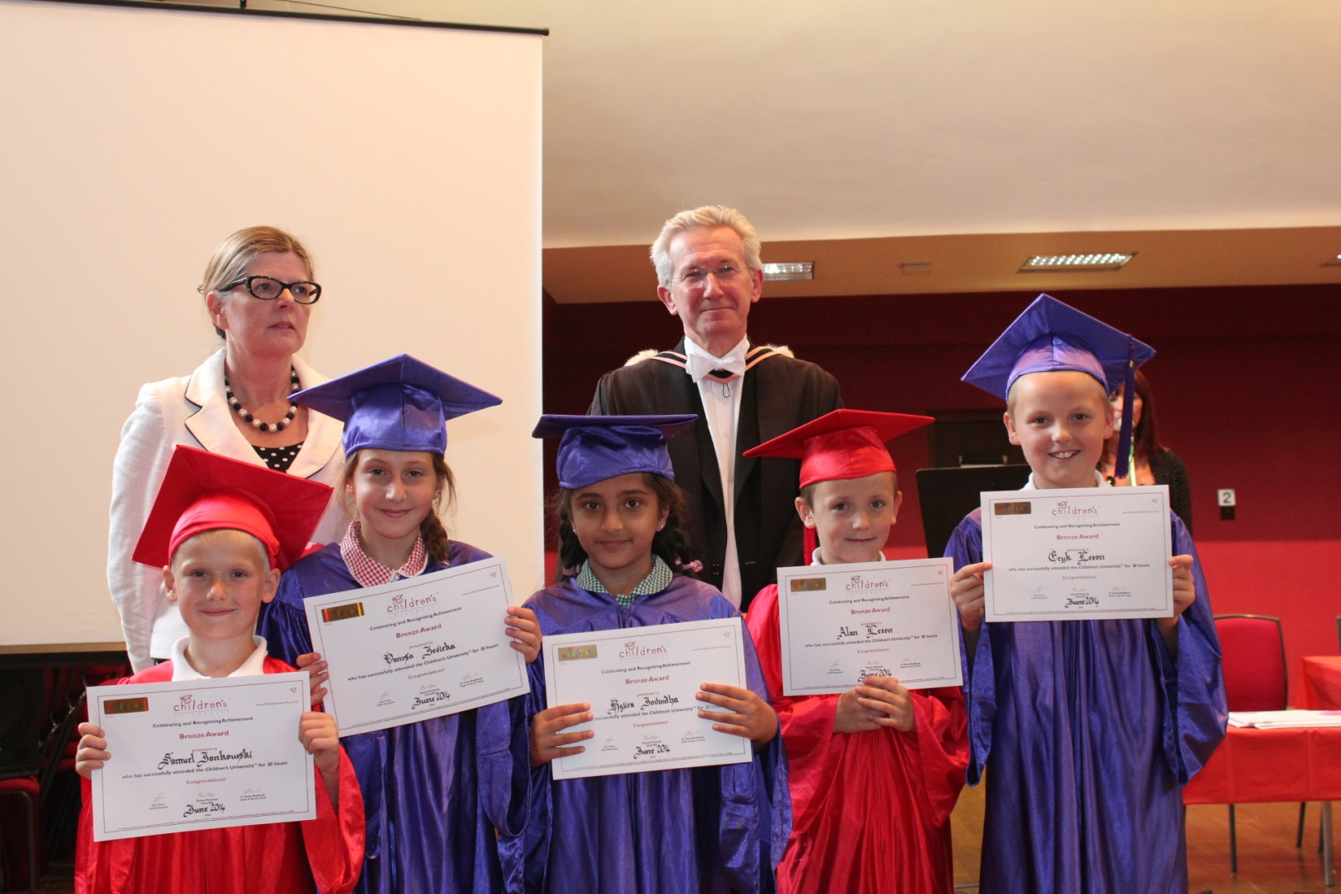

Marish Academy held their first graduation event at Eton College this term. We have been graduating at Royal Holloway University for the last three years but now have so many pupils to accommodate that we held a separate ceremony at Eton for pupils with 100 hours or less attendance. We still have our graduation at Royal Holloway next week for the pupils who have achieved hours in excess of 100 at CU activities.

As an Academy we are very proud of our work with Eton College. Last term, Eton staff and pupils ran several CU sessions for us including a design technology club, a history club and the very popular 'Eton Experience' where pupils visited Eton College each week and learnt a different aspect of the life and history of the college. The activities included playing Eton fives, a game only played at Eton, visiting the oldest part of the school and visiting the Natural History museum; a CU learning destination in its own right.

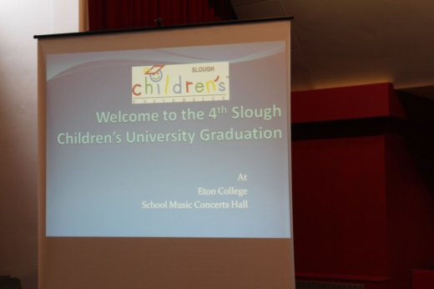 | 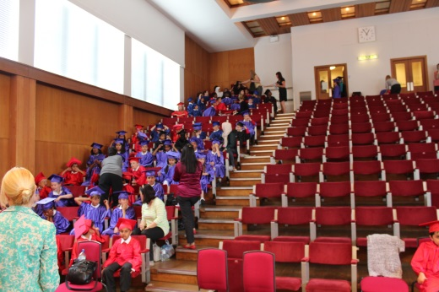

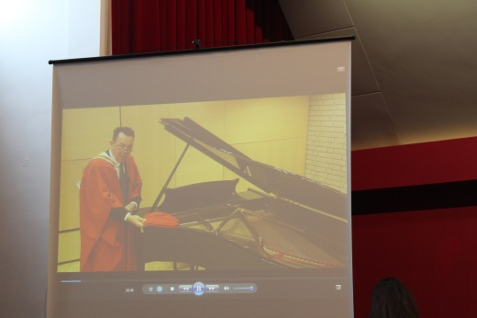 | 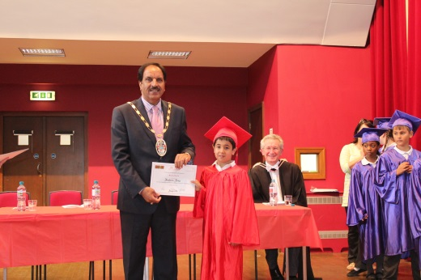

We were warmly welcomed to the College by their Master responsible for outreach, Mr George Fussey and a sixth form student, Hordon, who helped set up and deliver their workshops last term. The certificates were issued by the Mayor of Slough who spoke briefly about links between Slough and Eton commencing when the historic bricks for Eton were made in Slough and how he was pleased to see the links continuing and developing through the Children's University.

Over one hundred parents attended to watch their children graduate. The event was so successful that these links will continue and develop during the next academic year.

