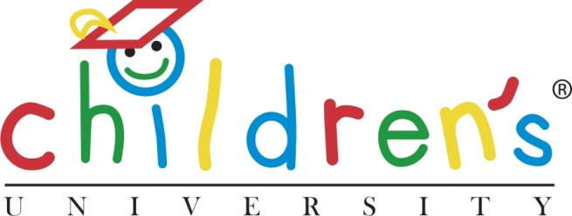

Ref CU/002/2014
November 2014

Children’s University Down Under
Whilst Children’s University (CU) UK is preparing for its annual winter conference in December, around the world the green shoots of spring are already celebrating the achievements of the newest members of the CU family.
Children’s University Australia held its second graduation at the University of Adelaide earlier this month, with over 100 graduates and their proud families attending the ceremony. After a stunning ceremony in Bonython Hall, the traditional home of all the University of Adelaide’s graduations for adult students, the fledgling graduates had a taste of student social life with a celebration barbecue and party.
Kiri Hagenus, Director of CU Australia said “The University of Adelaide is thrilled with the way CU Australia is growing. We now have 23 schools participating with 1,800 passports to be active in January 2015. This is quite an achievement since the initiative began with one school and 45 passports one year ago. We have exciting plans for the future including bringing the benefits of CU to other areas of Australia in the near future.”
Meanwhile over in Malaysia, a pilot CU project is about to hold its first graduation. The students have used their passports for a range of innovative learning activities, and some have also worked towards a new Leadership Award, getting a head start to develop the skills they can bring to the world of work.
With plans for a new CU to start shortly in Shanghai, spring has definitely arrived early for Children’s University!
/ends/
Press enquiries: Anna Donaldson, Beacon PR M: 07779 843624
E: anna@beacon-pr.co.uk

The Children's University (CU) Trust offers 7 to 14 year olds (and 5 to 6 year olds with their families) exciting and innovative learning activities and experiences outside normal school hours. It's an organisation which signposts children to exciting learning activities which take place outside the normal school day - it could be before school, during lunchtime, after school, during weekends or holidays etc. The activities are all voluntary, and help children to chose what to do and when, giving them the opportunity to sample activities they might not otherwise have access to.
All children receive a ‘Passport to Learning’ which is stamped with the activity and the number of hours they have completed. There are over 115 CU destinations in the UK with activities that are practical, fun based and voluntary and include after‐school clubs, community activities, and learning at museums and theatres, in parks and galleries and even at B&Q and the BBC. There are also CU developments in the Netherlands, Italy, Portugal, Australia, Singapore, Malaysia, China and India.
An important principle of the Children's University is that participation is voluntary and it is intentionally something other than school - with a different feel, different activities and often a different location, peer group and staff. At the heart of its work is the ambition to raise aspirations, boost achievement and foster a love of learning. It enables young people to make the most of their abilities and interests, regardless of the background into which they were born. The Children's University aims particularly to reach children and young people facing socio-economic disadvantage through the targeting of grants to, and the promotion of activities in, areas of deprivation.
The ultimate testament to the effectiveness of the Children's University is that young people give up their time to attend. They begin to realise that learning can be "...a satellite navigation system to better places in life…". The significant increase in numbers over the past year shows they do indeed attend, and the comments and recommendations of parents, teachers and the children themselves show they are engaged and inspired too.

