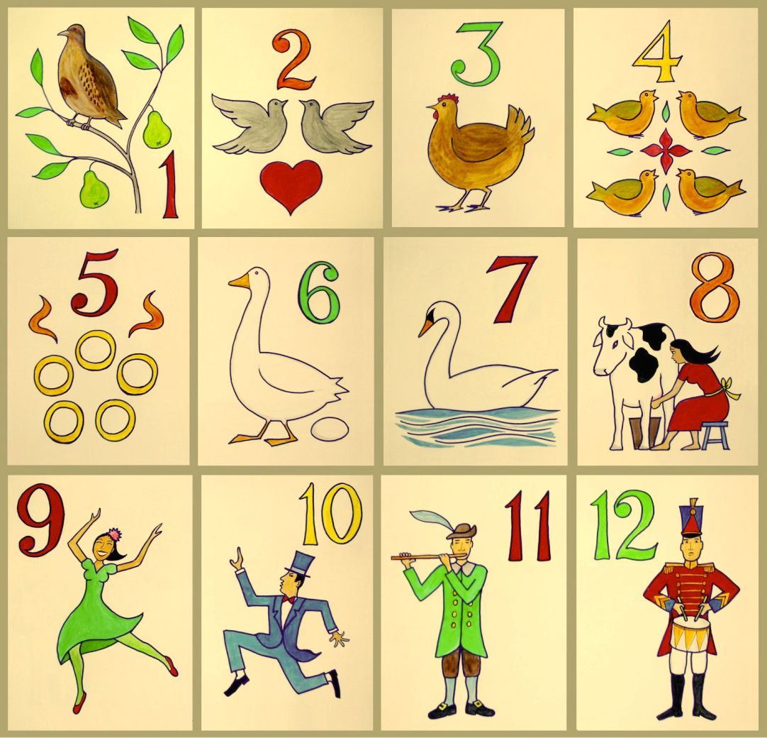

*Read The Night Before Christmas’ & write a short poem in a similar theme*

*Learn a new Christmas Carol & go Carol singing*

*Send us a Christmas Limerick!*

*10 facts about the ‘REAL’ Father Christmas*

*Make cookies & deliver to someone special*

*Make a Christmas ornament & email us the picture!*

*Five facts about reindeers & name the special 9*

*Create a Christmas pop-up card!*

*What’s the % of poverty in your area? Drop a tin of food at a local foodbank*

*Do something caring/thoughtful for someone in your community*

*Build a wildlife home in your back garden*

*Write a 100 word book report after a visit to your library*

**So… You have decided to take up the challenge!**

**Here are some rules**

If you have a Children’s University **Passport To Learning**, you will receive 1 hour for each of the activities you complete.

You must provide some evidence, to your school, that you have taken part in the activity. For example, you could take a photograph, write a diary, draw a picture of your activity, make a voice/video recording or bring your creations in to school.

You might like to include the following in your evidence:

* When did you complete the activity?
* Who were you with?
* C:\Users\Penny.Wolfe\AppData\Local\Microsoft\Windows\Temporary Internet Files\Content.IE5\ZQY20QE9\MC900410553[1].wmfWhat was the weather like?
* Did you have fun?
* What did you learn?