Do a scavenger hunt at the beach/forest. Find natural resources and create a winter scene | Find information about the WW1 Christmas Day truce (football game) and write a summary | Visit your local library and discover how countries around the world celebrate Christmas and design a poster | Make a large map of your local CU and put on all the Learning Destinations you have visited | Bake some mince pies and biscuits for Father Christmas
Research a piece of art that you like and try to draw it. Who is the artist, when was it painted, what type of art is it? etc. | Explore a new Learning Destination and write a review | Research an animal that lives in the Artic or Antarctica and create a fact sheet | Design and create a Christmas card and send to a teacher | Write your own version of the 12 Days of Christmas
Interview family members and discover your own Christmas traditions | Write a winter fairy tale | Complete a Nature Detectives winter activity sheet | Create a marketing campaign for your local CU including a slogan, song and merchandise designs | Learn and sing Christmas carols for your family and school
Research how different cultures celebrate New Year's Day | Visit your local library and find out about Hanukkah | Using a variety of resources (visit a library, museum etc.) research a local historical figure and write a face file | Display to friends, family and your local CU a new skill you have learnt at a Learning Destination | Make a festive decoration using recycled resources

So… You have decided to take up the challenge!

Here are some rules
If you have a Children’s University Passport To Learning, you will receive 1 hour for each of the activities you complete.

You can take part in the Winter Activity Challenge even if you are not a Children’s University student. To become a student it is very simple, just visit your local library and purchase a Passport To Learning and begin earning stamps.

You must provide evidence of each activity you complete to your school or local library and depending on the challenge, there are many different ways to display your work, for example:

- Photographs
- Write a diary/newsletter/scrapbook
- Draw a picture/poster
- Make a voice/video recording
- Bring your creations in to school/library
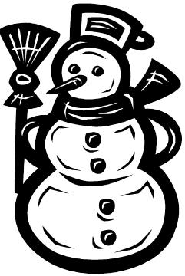
- Tell us when you completed it, who with, what steps did you take etc.

