PRESS RELEASE - FOR IMMEDIATE RELEASE – 3RD FEBRUARY 2013

Musical masterclasses for Nuneaton schoolchildren
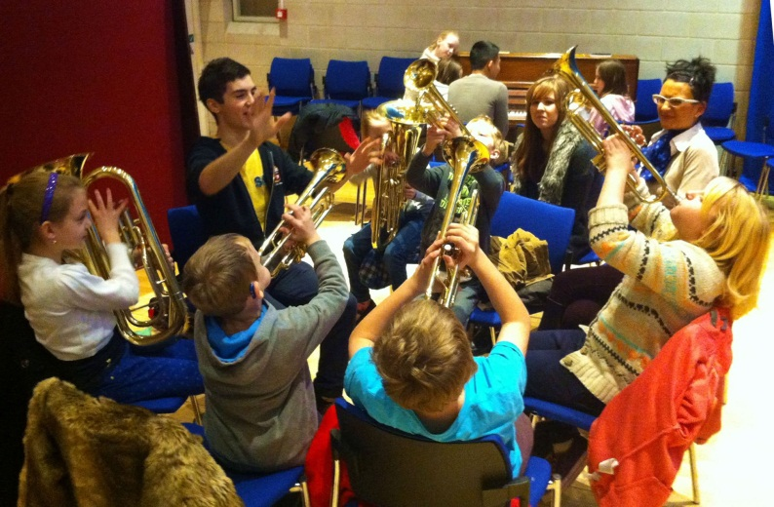

A group of 15 children from Wembrook Primary School in Nuneaton have been spending Saturday mornings undertaking musical master classes, called Musical Maestro, at the University of Warwick. Musical Maestro has been created for the Children’s University scheme, which encourages children from all backgrounds to participate in extra-curricular activities.
The master classes are for children with little prior musical experience and are delivered by three Lloyds Scholars students at the University of Warwick: Harrison Gould, Michael Shneerson and Jordan Choy. The Lloyds Banking Group Lloyds Scholars programme offers students a complete financial and support package during their time at university. In return, Lloyds Scholars are expected to volunteer a minimum of 100 hours in their local community. Musical Maestro is also supported by Warwick Volunteers, a university organisation.
Over the course of five weeks, the children have the opportunity to learn the piano, bongos, trumpet and euphonium. Lloyds Scholar Harrison Gould explains “The children love it, we enjoy running it, and the feedback from teachers has been fantastic. It makes getting up early on a Saturday morning all the more worth it, especially as music is not as accessible to all children.
“All students involved with Musical Maestro are passionate about music and are all at least Grade 8 in our instruments. One student, Jordan Choy, has performed in the Royal Albert Hall. It is great to have such expertise within the group.”

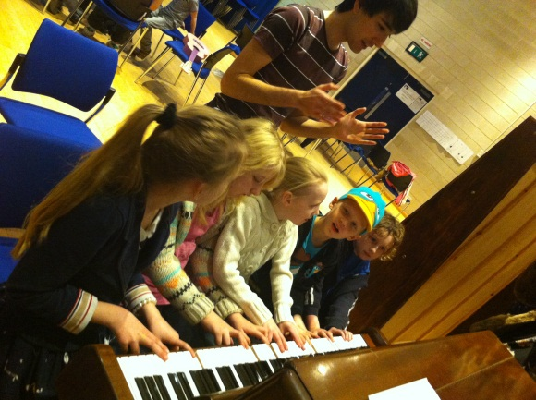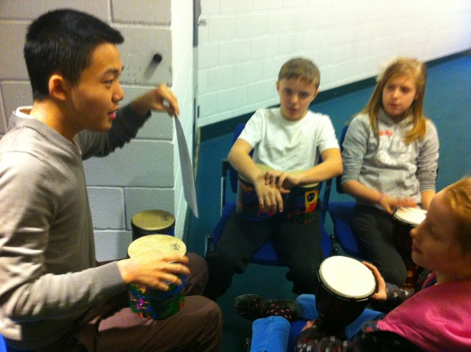

A syllabus has been created which involves a practical performance element as well as background musical theory. It is hoped that Musical Maestro can be taken to more schools in the coming months through the UK wide Children’s University scheme, and will ultimately encourage more children to learn an instrument.
[END] 288 words

Contact details:
Harrison Gould
harrison.gould@warwick.ac.uk

Notes to editors:
- Lloyds Scholars is a unique social mobility programme run by Lloyds Banking Group. The programme aims to open the doors to students to go to a leading university and increase social mobility. More information: http://lloyds-scholars.com/
- The Children's University aims to promote social mobility by providing high quality, exciting and innovative learning activities and experiences outside normal school hours. More information: http://www.childrensuniversity.co.uk/about-us/
- Wembrook Primary School: http://www.wembrook.warwickshire.sch.uk/
- Musical Maestro classes take place over 5 Saturdays 9-11am in January and February

